VCP DTM-2020
Section 1 - Install and Configure Horizon Server Components

Objective 1.1 - Describe techniques to prepare environment for Horizon

2 Introduction to VMware Horizon
• Recognize the features and benefits of VMware Horizon
• Identify the major function of each VMware Horizon component
• Define a use case for your virtual desktop and application infrastructure

Components of Horizon:
Horizon Connection Server (View connection server)
Horizon Agent (installed as View Composer or Instant Clone)
Horizon Composer Server and DB (optional – only needed if using linked clones)
ESXi+vCenter Server

Horizon Licensing (enterprise and advanced): either
- CCU concurrent connections (i.e. number of connected desktop sessions)
- Named user (1 name, but they can have multiple sessions): good if dedicated access required all day – named user license is consumed for 60 days after last log off. Unless the employee is terminated (license then free’d up)
- You can mix CCU and Named , but not recommended.
- Enterprise edition contains JMP components but you can do RDSH with Advanced.

- HOWEVER! If users request a non-Horizon app i.e. 3rd party SaaS app via Horizon, then their license will be checked out for 8 hours. The cumulative unique number of users logged in should not exceed the concurrent usage license count.

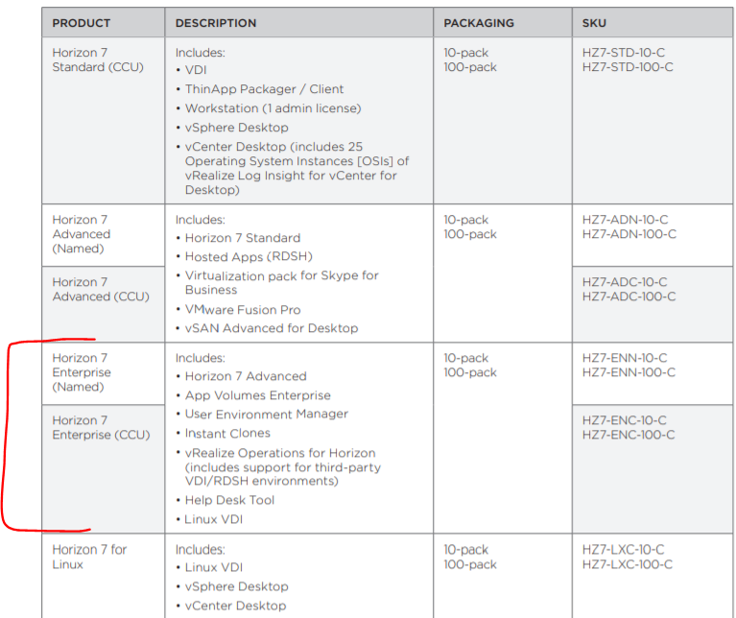

vSphere Desktop Licensing
- Licensed by Per-powered on VM (including ESXi hosts that host the environment)

AppVols
- 3 editions – Standard (inc, AppVols + UEM ), Advanced, Enterprise
- Named or CCU
- Supports RDSH, XenApp, XenDesktop, Horizon

UEM licensing:
- Per named user, or CCU

Licensing Identity Manager:
- Identity manager can always be used to access a VDI or RDSH app, and it will count as part of the CCU license.

Objective 1.2 - Determine procedures to install Horizon Components
3 View Connection Server
• License VMware Horizon components
• Use the dashboard to quickly focus on the details of a problem
Dashboards > System Health
• Identify the system and virtualization requirements for a View Connection server
Installing View Connection Server:
Supported Linux OS’s: Ubuntu, RHEL, Centos, SLED, SLES, NeoKylin
Supported Windows OS: Windows Server 08 R2 SP1 (Must use SP1) and 2012 R2 only.
Supported authentication protocols: True SSO, RADIUS, RSA SecurID, Smartcards
Installing gambits: 4cpu, 4gb, 10gb +, static IP and reverse lookup record

- An AD LDS is required (in server Roles/Features) and created for the horizon connection server to create entry points that Horizon will use (and download AD) information for use with Horizon. AD LDS is a copy of AD directory.
- Connection server must be joined to an AD domain:
- IPV6 is supported, but cannot be mixed with IPv4, only 1 stack can be used.

Domains you can join a connection server to:
- The Connection Server domain
- A different domain that has a two-way trust relationship with the Connection Server domain
- A domain in a different forest than the Connection Server domain that is trusted by the Connection Server domain in a one-way external or realm trust relationship
- A domain in a different forest than the Connection Server domain that is trusted by the Connection Server domain in a one-way or two-way transitive forest trust relationship

Repica Server Installation
- If expanding the environment, you re-run the same installer and install a Replica Server – this will clone the AD LDS from your initial install.
- To install:
  - Silently: pass the #2 and ADAM_PRIMARY_NAME=cs1.companydomain.com property to point to the server being replicated from.

- Security server provides environment access without VPN (legacy, replaced by UAG).
- Enrolment server – used for providing certs to users.

AD Accounts Requirements for View Connection Server:
Groups/Permissions:

- 1x View Composer User (if using composer) for AD operations (delete machine account, create kiosks etc) :
- List Contents
- Read All Properties
- Write All Properties
- Read Permissions
- Reset Password
- Create Computer Objects
- Delete Computer Objects
1x Instant Clone User Account – Create Compute Objects and Write All Properties permissions
1x vCenter Server user for Composer to perform operations in vcenter.

• Configure View Connection Server
During installation:
- Authorize Local Admins group or Domain User Group to administrate the console
- Point it to vCenter Settings > Servers > vCenter Servers
- Associate vCenter server with your View conn server (accept SSL thumbprint), choose whether to enable Reclaim VM disk space and Enable View Storage Accelerator.

How to Upgrade SSL certs from self-signed to a certified CA:
- SSL certs can be Self Signed, Single-named or Wildcard SSL certs.
- Self-signed cert will produce a warning when accessing the Admin dashboard.

Installing or installing a new TLS/SSL connection server cert:
- Get TLS cert from CA
- Import SSL/TLS cert into View Connection server local machine > Personal Certificates store
- Modify cert Friendly Name to vdm > MMC > Certs > Local Computer> Personal>Properties (remove /change the expired certs friendly name from ‘vdm’ to something else
- Configure client to trust Root and import any Intermediate certs authorities if necessary.
- IF running composer - now Bind the cert to the View Composer server:
  - Stop View Composer service
  - Launch C:\Program Files (x86)\VMware\VMware View Composer\sviconfig.exe
  - Run: sviconfig -operation=ReplaceCertificate
-delete=false
  - Restart composer service

Add an events db (optional) >Settings > Event Configuration
Join to AD domain: Administration > Single Sign On> Configuration > AD Domain
License it: Settings> Product Licensing and Usage >

• Identify the benefits of using the VMware Horizon Help Desk tool
Horizon Helpdesk Tool:
Available in Enterprise edition and Apps Advanced
- Helpdesk Administrator pre-defined role available (and read-only role available)
It’s a web application that integrates with Horizon console to allow remote control options like:
- remote assistance,
- user session metrics,
- terminate process/logoff/reset,
- send a message to desktop.
- Blast sessions statistics, hardware performance, utilization metris for CPU, memory, disk
-Tool installs as part of view connection server (installed by default)
-Remotely kill processes from the horizon dashboard on a desktop

View Composer Installation
- View Composer can be installed on the vCenter server or on a standalone box
- Ideally in a one to one relationship (one vCenter server to one Composer server)

Pre-requisites:
- 4gb RAM, recommend 8
- 4 CPU core and minimum 1.4ghz,
- 1gbps network. Recommended is 10gbps.

Database Requirements – can use the existing vCenter server DB (for events)
- Must be SQL!
  - 2008 R2 SP2 or SP3
  - 2012 SP2
  - 2014 with or without SP1
  - Oracle 12c
-ODBC connection (system DSN)
- View Composer server should be able to resolve DNS for the DC
-User account with priv to add/delete computer accounts on AD
-RSA key pairs are created (or can use pre-existing ones) to encrypt the authentication data in the data in the View Composer db.

Key Points for Connection Server Environment:
Keep TCP 443 open

Objective 1.3 - Determine steps to configure Horizon Components

Horizon Dashboard Overview:
Health Pane Status Flags:
Green/Yellow/Red – component unavailable.
Grey or ? = View is not sure of status

Desktop status:
Provisioned = available, ready but powered off (slight delay in logging in while powers up)
In Pairing = desktop is powering on

Event Filter: only displays the last 2000 events

Horizon Agent Requirements:
- For most recent agent releases, only older Win 10 releases are valid – have to refer to interoperability matrix
Horizon Agent Configuration:
- The GPO templates for Horizon Agent (vdm_agent.admx) let you configure useful stuff:
  - AllowDirectRDP
  - CommandsToRunOnConnect
  - Enable multi media acceleration
  - Default proxy server
  - Force MMR to use software overlay

Real Time Audio-Video kernel mode lets you use locally connected devices (webcam, mic) pass through to the desktop
- Doesn’t support RDS

Supported Features for Linux Horizon Agent

Horizon Agent for Linux Installation
- Unpack the download .tar file on the linux of
- Run install_viewagent.sh

Horizon Agent Fails to Register
- Password contains a special char that was not escaped
- User doesn’t have the ‘Agent Registration Administrators’ or ‘Administrator’ role in Horizon
- FQN, pw or username was incorrect during install

Horizon Agent for Linux limitations
- Virtual printing, location based printing, and realtime video , HTML access file transfer not supported
Horizon Agent Features:
Horizon Skype For Business Virtualization Pack
-Creates a connection outside of the VDI desktop session to connect skype sessions – which puts emphasis on the display protocol/VDI to do the processing, not the VDI.
- Bandwidth usage is optimized as per native SFB calls.
What does it use?
- Horizon Media Proxy – lives on the VDI desktop
- Horizon Media Engine – processes all audio and video, lives on the endpoint
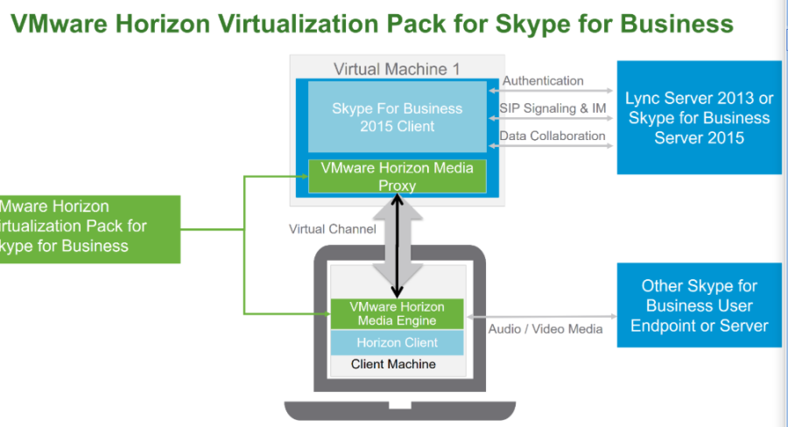
Multimedia Redirection
- Similar to skype, MMR offloadsmedia processing to the client machine
- Default setting is denied, needs to be enabled in Horizon admin console
- Media Data is unencrypted! May need security insight.

Session Collaboration
- Share screen and control with multiple people. Connectee’s must use their AD creds to connect.
- Shadow control, revoke/end sessions, primary monitor is only one displayed.
- Enabled at pool level or farm level (RDSH) or via GPO.
- Session Collab icon lives in system tray
Limitations:
- Not supported with Linux (desktops or published apps)
- Users can’t change resolution of collab session
- Can’t have multiple collab sessions
- Cannot use MMR, USB , smart card, file redirection etc. ‘ View and control’ only

Admin Console takes a long time to load? Set logging to INFO.

Horizon FIPS Mode
- TLS v1.2 must be enabled

16 Command-Line Tools and Backup Options
• Describe key View Connection Server features that are available as command-line options with the
vdmadmin command

- Kiosk Mode
- Domain Filtering
- Display first user of a machine
- Remove view connection server instance
- Unlock/Lock Vms
- Override IP

- Explain the purpose of kiosk mode for client systems and how it is configured

Pre requisite recommendations:
- Create a separate OU for kiosk machines and a group name for them, for easier administration.
- Prepare desktop image with disabled power settings, view agent installed etc
- Desktop entitlement for the kiosk user group

Kiosk Mode:

- Set default values for kiosk accounts that are created in view:
vdmadmin -Q -clientauth -setdefaults -ou "OU=kiosk-ou,DC=myorg,DC=com" -noexpirepassword -group kc-grp

- Verify defaults are set:
vdmadmin -Q -clientauth -getdefaults

- Create user accounts and add clients to the conection server: example w/ fixed pw:
vdmadmin -Q -clientauth -add -domain MYORG -clientid custom-Terminal21 -password "guest" -ou "OU=kiosk-ou,DC=myorg,DC=com" -description "Terminal 21"
- A user account in the format: Cm-XX_XX_XX_XX_XX is created

- Enable the conn. Servers to authenticate clients:
vdmadmin -Q -enable [-b authentication_arguments] -s connection_server [-requirepassword]

Domain Filtering:
- Whitelist/blacklist domains on groups or individual connection servers- the main benefit in multi-domain environments reduces the search/resolve time the conn. Server needs.

View Host Script Service:
- Enable this for RDSH scripted load balancing, but it is also needed to be able to run scripts on the horizon environment.

PowerCLI Horizon Modules
Downloaded from the powershell gallery
- Install-Module -Name Vmware.PowerCLI

• Identify the log locations for each VMware Horizon component
Log File Location for Horizon Components
Client: %appdatalocal%\VMware\VDM\logs
Conn server: Support.bat or prog files\vmware view\server\DCT
View Composer (on a desktop): %temp%\vmware-view-composer-ga-new.log
Horizon Agent: %programdata%\vmware\VDM\logs
OR collect remotely from a conn server, use: vdmadmin –A –getDCT –Outfile filename.zip –d pool_name –m vm_name
AD: Event viewer
UAG: zip files via UI interface > Support Settings, logging level if INFO by default.
vROPS Broker agent: C:\ProgramData\VMware\vRealize Operations for Horizon\Broker Agent\logs
vROPS Desktop agent: C:\ProgramData\VMware\vRealize Operations for Horizon\Desktop Agent\logs

Describe the backup options for VMware Horizon databases
Backing up Horizon:
Horizon backs its own DB up
- AD LDS and View Composer DB are backed up 12 midnight, everyday
- Keeps 10 backups by default in C:\Programdata\VMWare\VDM\backups
- Manually backup the db by clicking ‘Backup now’ on the preceding menu
- View backups by browsing to Horizon Console > Servers> Connection Server > see the ‘Last Backup’ column.
- View composer service must be running for backup to be successful
- During a backup, any operations/tasks taking place at time of backup may not be captured in backup, so manual reconciliation may be necessary.
You can also use the vdmexport.exe utility to backup the View Conn LDAP db:
C:\Program Files\VMware\VMware View\Server\tools\bin\vdmexport.exe

How to restore View Composer:
- Stop the View Composer process:
  - net stop svid
  - Use sviconfig to restore the db
  - Net start svid
- After this restore the AD LDS db too

Resolving DB inconsistencies:
- Example of an inconsistency – Horizon failing to delete a pool or showing status as ‘deleting’ , can’t delete a pool or desktop etc
- Use ViewdChk to try and sync the 3 databases (AD LDS, View Composer db, vCenter Server db)
- It never deletes user data.

Orphaned VM’s
- View connection server database might not match with the vCenter Server DB and thus, show VM’s as orphaned.
- VMs exist in vCenter but are unknown to View Connection Server
- Someone has removed a VM from an ESXi host inventory but it’s still in vCenter
How to fix orphaned VMs:
- Restart management agents on the ESXi hosts that hold the orphaned VM’s
- Restart the VPXD service (vCenter Server service)
- Re-register the VMX file of the VM with vCenter (browse datastore)
- If an instant clone pool contains orphans – unregister the VM’s from vCenter, delete them from Administrator.

17 VMware Horizon Performance and Scalability
• List several best practices for multiserver deployment in a pod
• Describe the benefits of the Cloud Pod Architecture feature for large-scale VMware Horizon deployments
• Establish a session with a desktop machine in a different pod by logging in to a local View Connection
Server instance
• Create global entitlements for accessing Horizon Desktops

Describe the purpose of a replica server
Single Pod and Cloud Pod Architectures
Single Pod:
- A single Pod can have a limit of:
  - 12,000 sessions (per pod)
  - 7 View Connection Servers (5 internal, 2 external)
  - Anything above this can be integrated to a cloud pod architecture using load balancers
- Back to single pod architectures:
  - Tunnel connections use more overhead
  - Direct connections allow around 30% more load
  - A replica server (copy, in name only) is a copy of the standard, and pointed to an existing standard connection server (peer), they operate in the same hierarchy (i.e. replica is not a secondary) and replicate AD LDS changes between them. They’re identical in configuration/operation.
  - TCP 389 is used between each connection server to replicate changes

Useful :
- A single vCenter server instance can provision 20 desktops at a given time. By adding multiple vCenter server instances to your Pod (limit of 5 per pod) you can provision at a greater rate

Cloud Pod Architecture
- Scales up :
  - to 250,000 users
  - 50 view pods
  - 15 sites
  - 350 connection servers
  - Supports active/active DR to move desktop connections to a failover datacenter
- Uses global entitlements to permissions desktops across multiple sites
- Pod federation will redirect a connection to nearest datacenter

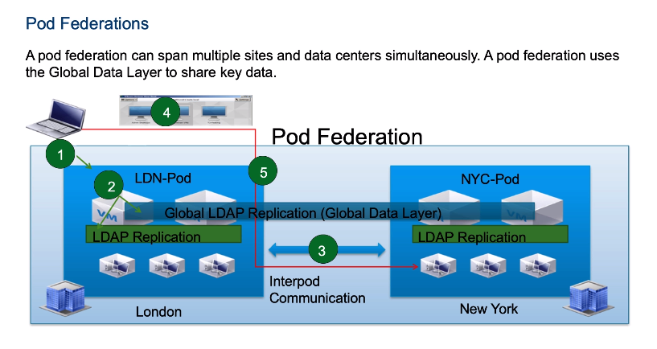

What’s different about Cloud Pod/How it works:
- A global Data Layer exists which consists of an additional LDAP instance (i.e. each connection server has its own LDAP instance, but the global one in addition to this)
- You can initialize the cloud pod architecture from any connection server, and the connection servers install the Global LDAP instance and replicate it amongst the other servers in the pod
- NEW MENU OPTIONS: The global entitlements appear under catalog and Sites appears under View Configuration.
- Global Entitlements: Search order =
  - Local resources first
  - Tries the site
  - Tries the federation

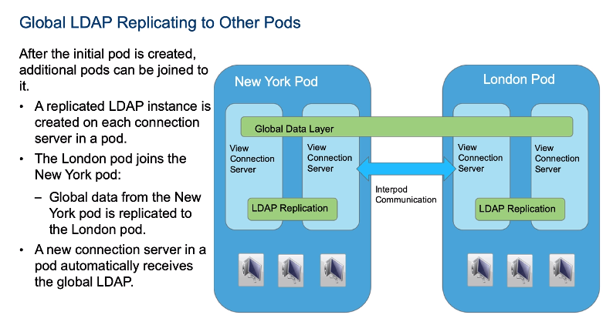

Limitations of Cloud POD:
- Kiosk mode is not supported
- IPv6 not supported

VMware Interpod API / Global Data Layer

- VIPA address is a mesh network that lives between each connection servr in a pod.
- One connection server per pod is a ‘representative’ / manages the communication of the VIPA.
- Every conn. Server in a pod has it’s own self-signed cert which replaces every 7 days
  - Use lmvutil --creatependingcertificate or –activatePendingCertificate

- This network replicates global entitlement info, topology info and can launch new desktops, find existing desktop and share health status info.

VIPA Port requirements:
HTTPS 8472 – VIPA communication
HTTPS 22636 – Global secure LDAP Replicaton
HTTP 22389 – Global Data Layer LDAP replication

Securing Horizon Connections, Security

Horizon Authentication

SAML / Workspace ONE Mode:
Pair a WorkSpace ONE node with the View Connection Server to provide SAML authentication and install a CA.
- In Workspace ONE mode you can block clients that don’t support Workspace ONE mode.

Smart Card for 2FA:
- Smartcard contains public key and private key
- 2FA with smart card + PIN number
- Requirements:
  - PKCS#11 or Microsoft CryptoAPI provider
  - Client devices need a card reader, middleware and drivers for their smartcard reader.
- Configure smart card removal policy on horizon (disconnect when card is removed? Enforce smart card auth or accept password?)

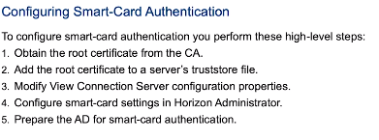
RSA: RSA server, tokens etc.
RADIUS: PAP, CHAP, MSCHAP1, MSCHAP2 supported.

Privileges and Roles

11 Managing VMware Horizon Security
• Compare tunnels and direct connections for client access to desktops
• Compare the benefits of using VMware Unified Access Gateway™ in the DMZ
• List the advantages of direct connections
• Discuss the benefits of using Unified Access Gateway
• List the two-factor authentication options that are supported by Unified Access Gateway
• Configure a Unified Access Gateway appliance

UAG and Securing Horizon Connections

Secure Tunnel Gateway Connection:
What is it:
- SSL connection between the Horizon Client and View Conn Server.
- Once connection is established, the session is encrypted on 4172 (PCoIP), 443 (RDP), 8443 (Blast).
When clients connect to a remote desktop or application with the PCoIP or Blast Extreme display protocol from VMware, Horizon Client can make a second connection to the applicable Secure Gateway component on a Horizon Connection Server instance, security server, or Unified Access Gateway appliance. This connection provides the required level of security and connectivity when accessing remote desktops and applications from the Internet.

Security servers and Unified Access Gateway appliances include a PCoIP Secure Gateway component and a Blast Secure Gateway component, which offers the following advantages:
- The only remote desktop and application traffic that can enter the corporate data center is traffic on behalf of a strongly authenticated user.
- Users can access only the resources that they are authorized to access.
- Supports Blast or PCoIP (respective to which Secure Gateway you enable, blast or pcoip) = better bandwidth utilization
- PCoIP and Blast Extreme are secured by AES-128 encryption by default. You can, however, change the encryption cipher to AES-256.
- No VPN is required, as long as the display protocol is not blocked by any networking component. For example, someone trying to access their remote desktop or application from inside a hotel room might find that the proxy the hotel uses is not configured to pass UDP packets.

Where is it configured?
- On Connection Server Settings > choose to enable PcoIP Secure Gateway/RDP Tunnel/Blast Secure Gateway (HTML and Blast extreme)

Why is it good/shit?
- Tunnel connections use 30% ~ more network overhead, which limits the # of sessions that can be in play.

Direct Connections
What are they?
Administrators can configure Horizon Connection Server settings so that remote desktop and published application sessions are established directly between the client system and the published application or desktop virtual machine, bypassing the Connection Server host. This type of connection is called a direct client connection.
With direct client connections, an HTTPS connection is still made between the client and the Connection Server host for users to authenticate and select remote desktops and published applications, but the second HTTPS connection (the tunnel connection) is not used.

- Used primarily for LAN/internal.
- Vulnerable to MiM attacks
- Less overhead on conn. Servers and faster.
- Can use all 3 display protocols.
- Not secure for use on internet
How to enable:
- Uncheck the ‘use secure tunnel connection’ in View Conn Server Settings.

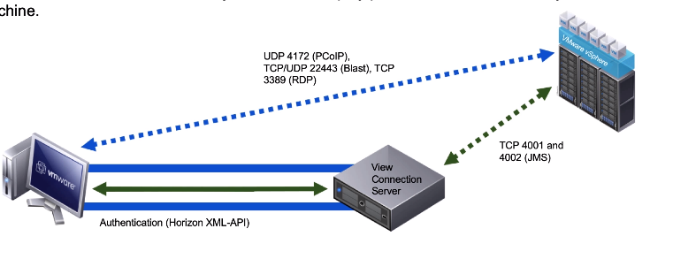

UAG

- Uses HTTPS, can be configured with a load balancer.
- Config is independent of View Connection server instances.
- Supports custom thumbprints for SSL proxies.
- UAG’s can sit behind load balancers, as can conn servers.
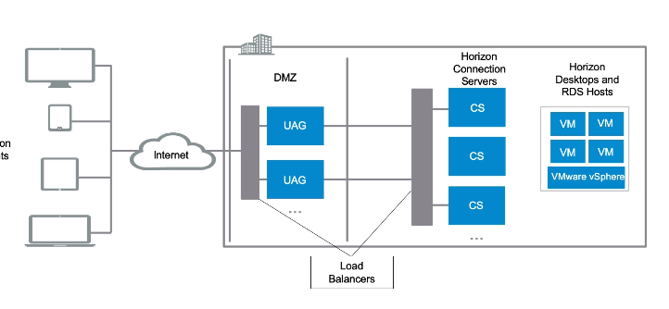

Supported UAG Auth Methods:
- RSA, AD credentials, RADIUS, SAML, Smart Cards

Smart card support for UAG:
- SSO to Horizon and RDSH apps
- UAG handles the authentication of smart cards

UAG Front end ports (internet facing):
Horizon Client: Port 80 and 443
Horizon Client (PCoIP): 4172 UDP
Web Browser(HTML access): 8443

22443 (blast)

Session Load Balancing on UAG

Source IP Affinity:
- When multiple connections are made , the load balancer will ensure that all subsequent sessions (Regardless of protocol) will route through the pre-existing session on the UAG.

Benefits: It uses standard port numbers, doesn’t require multiple VIPs.
Restrictions: Relies on source IP address which is not always possible (if you change your source i.e. your source IP changes).

Port Number groups?! Read more on this..
Load balancing options – Session affinity options= Port Number Groups
- UAGs are given port number groups for each protocol
- Primary connection is

Multiple VIPS:
- Example: view.company.com, view1.company.com, view2.company.com – multiple VIPs allow sessions to be load balanced across load and health.

Negatives: Costs more money (public IP’s/VIPS)

• Outline the steps to create a Horizon administrator and a custom role
• List some of the best practices for configuring Horizon administrators

Roles, Permissions and Groups
- Horizon uses pre-defined Roles (or custom) that contain permission sets/settings , and those permissions apply to groups of objects (or components) in the horizon environment.
- Access groups are like a folder, you add an access group to a pool, or object and then permission the access group
- Maximum access groups = 100

Create a Horizon Admin;
Settings > Administrators >Add Administrator or Permission > Search LDAP for a group or user > Assign a default role

Custom Role>
(Flex console) Administrators > Roles > Add Role

Best Practices for Horizon Admin Accounts:
- Limit the quantity of administrators
- Don’t use local windows OS groups for Horizon Admins, nested groups can sprawl permissions to the wrong users
- Try not to use word ‘administrator’ in the group name!
- Create separate admins that can modify global policies and settings

Objective 1.4 - Analyze End User Requirements for Display Protocol Performance

• Compare the remote display protocols that are available in VMware Horizon

Blast:
- Based on H.264 protocols.
- TCP / UDP 22443 , SSL for encryption (TCP) and DTLS for UDP.
- USB redirection (MMR)/Client Drive Redirection (CDR)
- Supports IPv6 (TCP only)
- Uses less bw than PCoIP, frame rates improved
- Can handle packet loss
- Less CPU, optimised power consumption for mobile devices
- Good for poor network conditions
- Integrates with GPO and UEM Smart Policies

Connection flow:
- Establishes connection over TCP 443, IP of desktop is returned to client over 443, then >
- TCP web socket connection is then made on TCP22443, then the Agent tries to establish UDP instead on a new web socket UDP22443 , if UDP disables, falls back session on TCP 22443.
- Additional side channels (for USB, drive redirection etc)
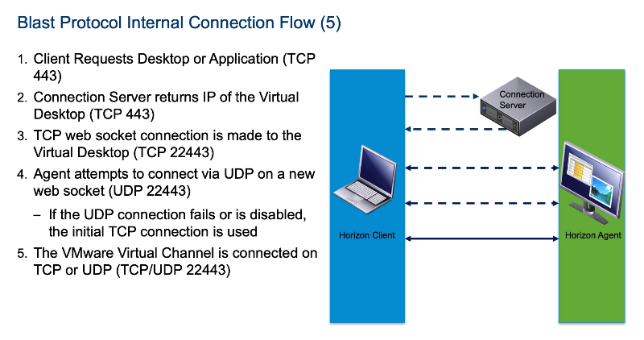
Blast Settings on Horizon Client
- Excellent (TCP only)
- Typical (default, mixed UDP/TCP)
- Poor (UDP only)
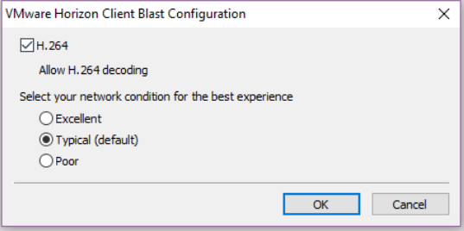

Blast policy settings:
/HKEY/Software/Policies/ VMware Inc/VMware Blast/Config
Or via UEM.
Import vdm_blast.admx file for GPO settings.

If the following VMware Blast policies change during a client session, Horizon Client detects the change immediately and adjusts the settings in session:
- H264
- Audio Playback
- Max Session Bandwidth
- Min Session Bandwidth
- Max Frame Rate
- Image Quality
- For all other VMware Blast policies, Microsoft GPO update rules apply. GPOs can be updated manually or by restarting the Horizon Agent machine.

Max Session Bandwidth: set in (kilobits per second – kbps), default is 1gbps
Min session bandwidth: default is 256kbps – this setting sets a reserve of bandwidth for a blast session
Reference the Blast Bandwidth Profile Reference to see how Horizon Smart Policies set their bandwidth dependent limits and settings.

PCoIP
- Developed by Teradici
- Has built in encryption and compression built in
- On LANs its faster and smoother
- Uses a ‘progressive build’ technique – a staged rendering of images that tries to maximise the quality of a session – it happens in stages as below and set via policy settings:
  - Initial image (low bandwidth, grainy, 0.2 to 0.5 bits per pixel)
  - Perceptually Lossless (build over a few frames, high quality picture and lossless text) – this is usually fine for end users
  - Lossless (5-15 bits/pixel) – lossless picture and text.

PCoIP ADMX Settings pcoip.admx:
Bandwidth considerations for PCoIP and how to configure
- Configure Frame rate vs Image Quality, Audio
- Maximum BW session
- PcoIP bandwidth session floor: minimum session bandwidth – good for addressing connectivity drops that occur on Wifi networks- reservesa session size to ensure quality.

- PCoIP session audio bandwidth
- Turn Off Built-to-Lossless feature – disable this setting if you want to save bandwidth.
- Configure PCoIP client image cache policy: lets you control how pcoip renders images during congestion – it caches on local machine to avoid retransmission. 90mb default cache size

RDP
- Encrypted mouse and keyboard data
- Sound, drive, port, network printer redirection
- Creates separate channels for each data flow (sound, video etc)
- Supports up to 16 monitors
- Copypaste, folder files between systems and the remote session
- 128bit encryption

• Outline the configuration choices when installing Horizon Agent
Horizon Agent Installation Choices:
- Choose View Composer Agent vs Instant Clone Agent
- Baseline enabled settings:
  - Real time audio-video
  - CDR
  - Virtual Printing
  - vROPS desktop agent
  - vmware audio

- Everything else is disabled: INCLUDING USB REDIRECTION! flash redir, scanner redir, advanced printing, html 5 redir, performance tracker, geo location

Horizon Performance Tracker
- Enable this to view the display protocol performance and system resources.
- Installed as part of the horizon agent installation (custom option)

Objective 1.5 - Diagnose and solve issues related to connectivity between Horizon server Components

VDMadmin can do:
-Configure kiosk mode clients
-Display user info
-Unlock/lock VM’s
-Override IP address
-Remove entries from view conn server instance etc

Section 2 - Create and Configure Pools

4 VMware Horizon Desktops
• Outline the process and choices in setting up VMware Horizon virtual machines
• List the steps to add desktops to the View Connection

Objective 2.1 - Configure and Manage Horizon Pools

5 VMware Horizon Desktop Pools
• Identify the steps to set up a template for desktop pool deployment
Configuring a virtual machine for use as a Master Image (specific order):
- Select hardware configuration
  - Minimum Hardware:
  - CPU: For Windows VM’s that need 720 video using BLAST or PCoIP –at least 2 vCPU is needed.
  - Memory: 4gb minimum recommended, scale from there. Use Limits, Shares and Reservations to tweak.
- Drop any unnecessary virtual hardware from the VM (floppy drives, DVD drives etc)
- Install Guest OS as ISO (Recommended) / Check Horizon Compatibility with Windows OS.
  - Only KMS is supported as licensing option.
  - Install VMware Tools and configure time sync (sync with ESXi host,NTP?)
  - If using RDP for display protocol or general RDP access, add domain global sec groups to local remote desktop user group + open windows firewall as needed.
  - Join to domain, install any native applications and do another round of optimization.
- Install Horizon Agent (you can enable remote desktop as a step in the installer)
- Optimize Guest OS (OSOT), disable power policies, disable unused ports (COM1, COM2 etc), adjust display (choose basic theme), set Background to solid colour, disable screensaver, disable windows search, delete all event logs, run disk cleanup+ empty recycle bin, disable windows update, disk defrag, scheduled services
  - Disable windows services:
    - Hibernation
    - Defrag
    - Superfetch
    - WSUS Update
    - Registry backup
    - Windows defender
    - System restore
    - Feed and Sync tasks
- Install UEM Agent
- Install AppVols Agent
- Prepare the VM as Gold template
  - Release IP address
- Shut down and take snapshot.

Preparing a VM for use in an Automated Pool:
- Remove the VM from the domain; shut it down, covert to template. Although you join to domain during image prep, it’s removed before converting to template.
- Create customization spec to include:
  - Set computer name
  - Use DHCP
  - Join AD, generate new SID.
  - Delete existing user accounts
  - Don’t log in automatically as Admin

NOW TEST! Run the spec against a VM and confirm:
- Machine boots, is joined to AD (computer account creates) and on domain
- Check DNS record is built
- VM will reboot twice as part of customization process

Creating an Automated Pool:
- Set the displayname (end user see’s this)
- Pool ID (internal) – can’t contain spaces!!
- Access Group: housekeeping/much like a folder to store the pool in.
- Remote machine power policy: What happens when users power off machine (Suspend or Power Off are useful for conserving resources).

Configuring Automated Pool Settings:
-With 3D rendering disabled, the max # monitors is 4. If enabled, max monitors is 2.
- 3D render is available to PCoIP, Blast and RDP,but not available to RDP if ‘choose protocol ‘ is disabled.
- It’s worth understanding what resources (vRAM) are available. Configuring vRAM allocation :

Software rendering uses 96mb of rendering (useful for less graphics intense apps) – the ESXi host uses software rendering.

Hardware based (intensive graphics): Must have GPU graphics cards in ESXi hosts, graphics card VIB and driver must be installed on the vm.
Physical rendering uses 512mb
Automatic is the default (recommended) after all GPU resources are reserved, ESXi uses software rendering to power on the VM.

3D Graphics Options:
Soft 3D: Good for: windows aero, MS Office, Google Earth – uses CPU rendering. The VM must be able to run DirectX 9 and OpenGL 2.1 apps without need of physical GPU. Virtual Hardware v8 required.

vSGA (virtual shared graphics acceleration):
- VMs share a physical GPU on the ESXi host.
- Suitable mid range 3d design modelling and multimedia.
- Hardware version 8 +.
- VIBs must be installed on ESXi host

vDGA Virtual Dedicated Graphics Acceleration:

- High end graphics.
- vDGA settings are preserved after refresh , rebalance and recompose operations.
- Requires GPU pass-through on ESXi host.
- Configure VM’s to use dedicated PCI devies.
- Graphics drivers must be installed on VM.

NVIDIA GRID VGPU
- vSphere 6.0 or later
- Dedicated physical graphics processing
- VM Hardware v11 or later
- License for full GPU features within the VM (plus drivers and VIB on host)
- The vGPU per GPU basically = the number of users per card

AMD Multiuser GPU using vDGA
- vRAM per VM is fixed and GPU engines are shared between VM’s
- vSphere 6.0 or later.
- VM hardware 11 or later
- Only supports Manual Desktop Pools.
- Flexible 3d profiles (from lightweight to heavyweight users)
- GPU pass through required on the ESXi hosts
- VMs need dedicated PCI devices configuring
- AMD ‘Predictable performance’ uses a slot size style metric to configure its usage if most users do the same thing.
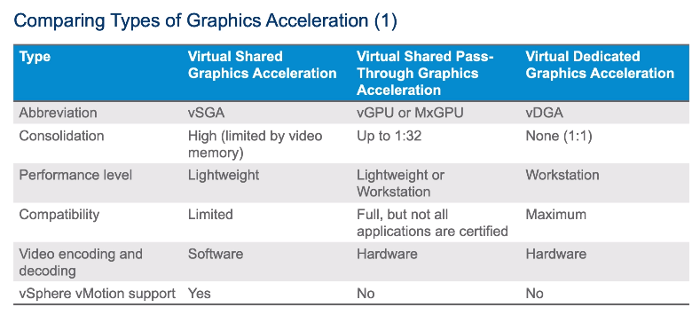
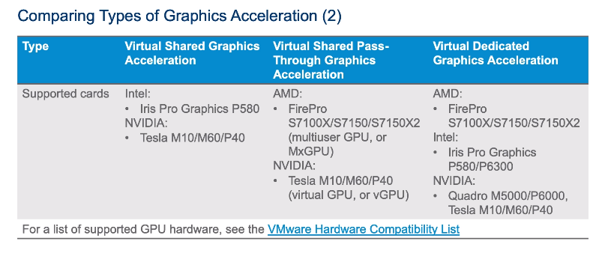
Horizon does not control 3D rendering, the settings are configured on the VM or pool setting. So it’s handled by vSphere.

Enabling Storage Accelerator
- Set on the pool settings during creation
- Instant clones must use this

Native NFS Snapshots (aka VCAI – View composer array integration) feature
- Lets the NFS disk array clones VM files (offloading the demand on ESXi and speeding up clone time.

Tags- tie specific user groups to specific connection servers – a tag = a user group (security group) – bit like connection server restrictions. Only displays pools available to that Tag.

Server inventory
• Define desktop entitlement
Restricted Entitlement
- Limits which connection server can be used to access a pool
- Restriction tag for a pool must match what a connection server see’s
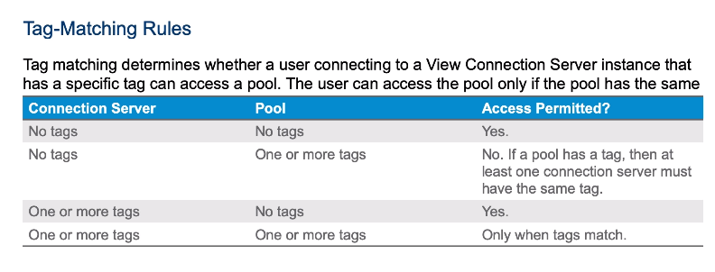

• Describe how information on the Users and Groups page can be used to control and monitor Horizon users

Entitlements, Users and Groups, Global Policies
- Users and Groups > ‘Update General User Information’ – if trust information has changed between configuration updates, you can click this to update user info.
  - It updates name, phone ,email, default windows domain.
  - It also updates external domains.
  - Scans AD for latest info.
- Unauthenticated Access tab > used to create user accounts that do not require domain AD credentials to access published applications only – cannot be used for desktops. You would use this for an app that has authentication built into it i.e. B1, Jira, a web app etc.
- Remote Access > lets you limit access from external networks coming into the desktops or applications to specific users or groups . Requires a UAG , Security server or load balancer outside the network to act as a gateway.

• Explain the hierarchy of global policies, pool-level policies, and user-level policies
Global Policies> Apply policies to all connection servers or a POD of servers.
3 Options for Global Policies:
- MMR redirection (best practice is allow this)
- USB access
- PCoIP Hardware acceleration – offload processing for PCoIP processing to a physical card (requires external card)
- Pool Level Policies take precedence over Global, and User level wins (if set). To configure: Desktop Pools > Policies tab and then User Ovverrides (optionally)

Administrator > Monitoring > sessions – to view open sessions.

• List the Horizon Group Policy administrative template files
GPO Templates Files

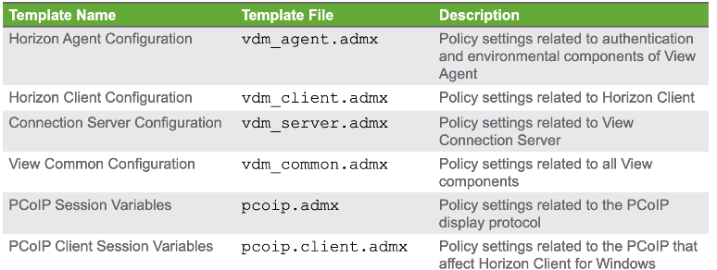
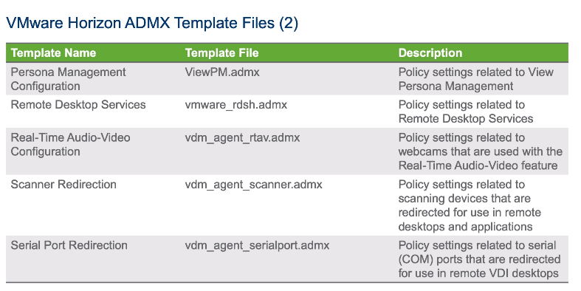

6 Horizon Client Options
• Enlist the requirements for a Horizon Client installation

Requirements:

- .Net 4.5 is required (installer downloads automatically if not present)
- All Windows OS EVEN 8.1 supported

• Install Horizon Client and connect to a virtual desktop
• Define and compare a thin client with a system running Horizon Client
Horizon Client Options and Settings:
- Horizon Client ‘Thin Client Mode’ exists if configuring with a thin client

Pointing the horizon connection URL to a unique version of VMware Client
- We edited the portal-links-html-access-properties file to force users to download a specific version of Horizon client.

- All settings below can be configured in vdm_client.admx file

Types of client: Mobile Thin Client, All-in-One client, Thin Client, Fat Client,
Zero Client :(no OS, just firmware, designed for remote access, usually protocol specific
Thin Client: small OS, memory, CPU, lightweight but cheaper than thick client

HTML access: Needs any HTML 5.0 browser
- IPv6 does not support HTML access
- Enable HTML access on the ‘Blast Secure Gateway’ area on connection server AND at pool level
- Connection server installs HTML access

SSO Timeout Configuration:
Horizon Admin > Global Settings > SSO timeout is set in minutes – after the time out, users have to reauthenticate. Also configure a grace period to auto log off users

Horizon Client for MAC:
Supports all the same features as Windows client.

Configure SSL:
Set whether to ignore SSL cert checking (and therefore, only use the self-signed SSL cert on a connection server) and allow the connection.
Deny connections to unverified SSL certs.

• Explain USB redirection and options
USB Redirection:
- Is installed with the Horizon Client install (as a component)
- Horizon Agent also installs the USB redirection component – DISABLED BY DEFAULT, if you omit the component during Agent install, it will not be possible at all to connect USB devices.
- Access can be controlled by DEM Smart Policies, View Agent GPO, or via Global, Pool and User Policies in Horizon admin console.

URL redirection:
Redirects a URL to load on your client device instead of using the VDI desktop e.g. heavy video/multimedia sites can load locally instead of on the VDI.
- Must use Blast or PCoIP
- Horizon Agent 7.0 or above

Client Drive redirection/Share Folders: present local drives to the VDI
- Controlled by Smart Policies, RDP group Policy, Registry settings
Serial Port Redirection:
- Local serial attachments can be redirection (configured in the view agent on the desktop image)
Flash redirection:
- As with URL, Flash processing performed on local device via separate TCP channel. Disabled by default – needs to be configured on the desktop (via Horizon Agent install) and on the horizon client settings.
- GPO’s let you manage the URL list , contained in vdm_Agent.admx

HTML 5 Multimedia Redirection:
- Reduces load on ESXi hosts, better audio and video experience.
- Horizon Agent must be 7.3.2 or later
- Requires a client device to have a browser redirection installed in Chrome or Edge.
- Horizon Client 4.6 or later

• Configure Virtual Printing for location-based printing
Virtual Printing
Requirements:
- Installed via Horizon Agent – there’s 2 versions – Virtual Printing (thinprint) and Advanced Virtual Printing
What does it do:
- Renders the print job locally on the client device using a universal print driver
- Requires full horizon client or thin client (some, vendor dependent)
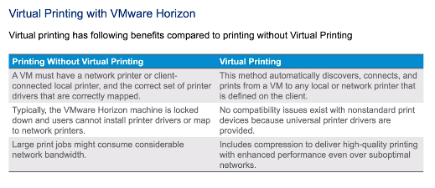
Locally installed printers are passed-thru to the VDI desktop
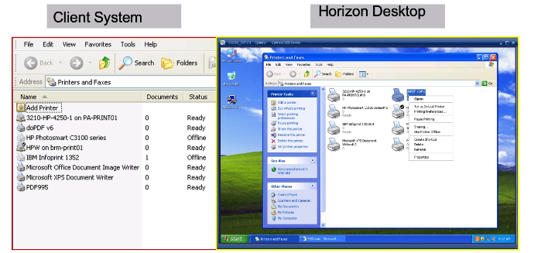

What happens?
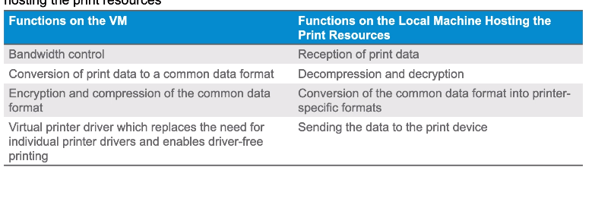

Location Based Printing (included in Virtual printing):
- Uses the subnet/IP of the end point device to map the closest printer
- Drivers for every printer must be installed in master image
- Done via GPO or registry

Advanced Printing Options:
- Cannot be used with Virtual Printing
- Does all the other features (printer redirection, location based printing)
- Allows printing from published desktop and RDS hosts
- Persists print settings
- Needs Agent v 7.7, and Horizon Client 4.10 and above.

7 Creating Automated Pools of Full Virtual Machines
• Recognize how an automated pool operates
Automated Desktop Pools:
- Can be cloned! But manual pools cannot.
- Cloning Automated pools can only contain Linked Clones or Full Clones
- Pools can only reside on one vCenter server

• Compare dedicated-assignment and floating-assignment pools
Enable automatic assignment: User is assigned a desktop automatically, but will receive the same desktop at next connection.

• Outline the steps to create an automated pool

Full Clones: Only sysprep is available for full clones.
Linked Clone: Only supports sysprep or quickprep
Instant Clone: Only supports cloneprep

Machine Naming conventions:
- Limited to 15 char NETBIOS
Specify names manually:
- You can upload a file containing computername@username to upload a set of names for VM’s manually.

Vmware Converter
- Convert physical and virtual machines for application across VMware tools like Workstation, Horizon.

8 Creating and Managing Linked-Clone Desktop Pools
• Describe the VMware linked-clone technology
• Enlist the system requirements for View Composer
• Outline the steps to install View Composer
• Outline the steps necessary to set up a desktop pool that uses linked clones
• Compare the purpose of the parent and the replica virtual machines
• Compare the recompose, refresh, and rebalance management operations for linked clones
• Describe the management operations for persistent disks

Linked Clone Pools
- Uses a read-from replica, and write-to-delta-disk technology.
- Linked clones anchor to the replica, not the parent VM, once the pool is deployed.
- Parent VM can be updated, but Replica cannot! Delete it, and the pool dies!
- When the first linked clone pool is built, replica is placed in the VMwareViewComposerReplica folder protected folder.

Recompose: Update the base image
Refresh: Resynchronizes linked clones to original snapshot ‘flush’ the disk/revert snapshot of vm.
Rebalance: Redistributes linked clones among datastores (load balances VM’s in a way, if 100 machine on 1 datastore, rebalance will delete and rebuild 50 on the 2nd datastore).
- Rebalance also triggers are refresh of the delta disks/data disk of each VM
- Only rebalances across shared storage, not local ESXi storage

Stub = a tiny file that ‘tests’ if provisioning can be done from the replica.
Disposable disk (optional) = user temp files, system page file, OS temp files written to these, deleted on log off.
Persistent disks only exist for dedicated pools – used to store user profiles if UEM isn’t used, or some third party solution is in place.
Gold VM+Snapshot = Replica
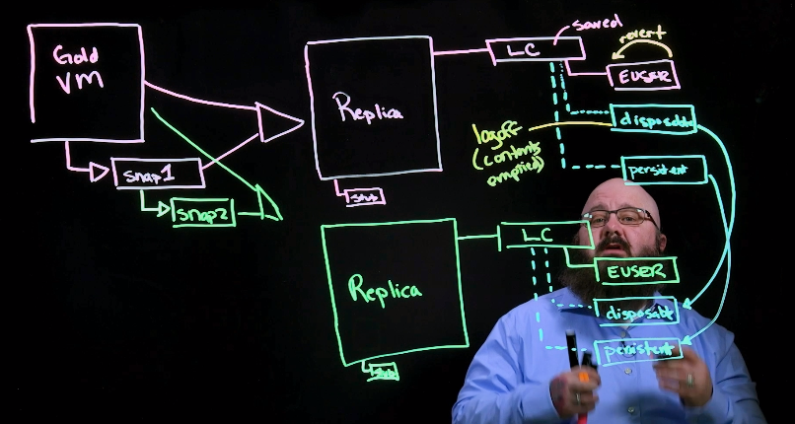

Persistent Disks:
- Only on dedicated assignments
- Moving a persistent disk to a linked clone: Resources > persistent Disks > detach if you want to move the disk between VM’s.
- Now attach it to a linked clone pool, this will create a new VM and associate it to the owner who the disk is associated to.
  - VM must run the same OS as the source (full clone) used.
  - To change ownership of a persistent disk, you need to change older ACL permissions to llow access.

Desktop Pool Settings – Linked Clones
Storage Over commit
-Default is conservative (which is 4 times the side of datastore, free space is used as buffer).
-Used to max out your available storage based on the premise that VM’s never grow to their maximum possible size

Refresh OS disk after logoff:

Linked clone sizing/datastore/infra considerations
-Capacity and size of a VM are not fixed; they can expand to the max size equivalent to a full clone
- Replica’s make a high IO read IOPS per VM – consider the disk type in your SSD/HDD, array type (cache size, software versions) and whether network uses FC or HBA.
-Consider putting Replica’s on SSD (high read) and Linked clone disks on high-capacity but low-read (HDDs) in below screen you can configure this!
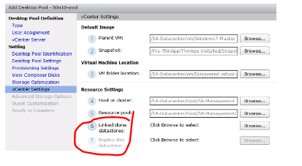

Advanced Storage Options and Tricks to improve storage use:
Tiered storage: splitting out the replica disks onto SSD, and data (i.e. clone disks) onto HDDs.

Use Horizon Storage Accelerator – ENABLED by DEFAULT - allows ESXi hosts to cache common VM disk data to improve performance, reduce storage I/O bandwidth to manage boot storms and AV scanning I/O storms.

Reclaim VM disk space:
- Does not work with vSAN.
- Reclamation initiates if the estimate of used disk space exceeds the specified threshold.
- Hardware version 9 or higher,

Quick Prep and SysPrep
- QuickPrep is vmware proprietary tool, quickly joins to domain, configures machine name but doesn’t change the SID of the machine (uses parent VM sid)
- Sysprep is Microsoft
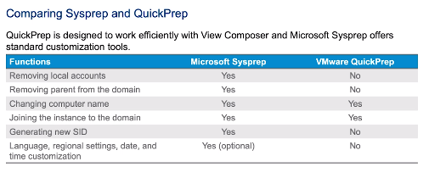

SIDS can affect licensing, so it might be necessary to refresh licensing during recompose operations.
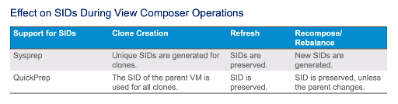

Troubleshooting Linked Clone Pools

Provision error (missing) Desktop Composer VcFault
Cause: Zombie vmware-ufad.exe process.
Solution: Restart vmware-ufad.exe process, rebuild the pool.

VM stuck in Provisioning State
Cause: Restarted view conn server mid provisioning or a network flap
Solution: Delete the VM’s and rebuild them

VM Stuck in Customizing State
Cause: Disk space – VM can’t start due to disk space
Solution: Delete the VM and Increase disk space or datastore space

VM’s stuck in Deleting State
Cause: discrepancy between data about a VM in vCenter vs AD LDS OR Network connectivity issue between vCenter/Horizon during pool deletion leaves the VM disconnected OR storage failure/someone deleted VM from vCenter but it exists in View
Solution: Rename the VM to its original name or sviconfig utility

9 Creating and Managing Instant-Clone Desktop Pools
• Identify the advantages of instant clones
• Differentiate between View Composer linked clones and instant clones
• Identify the types of instant-clone virtual machines
• Enlist the requirements of instant clones
• Outline the steps to set up an automated pool that uses instant clones
• Set of up an automated pool instant clones
• Update the image of an instant clone desktop pool using the push-image operation
Instant Clones

- TPS and Storage Accelerator enabled by default.
Benefits of Instant Clones

Requirements:
Master VM requirements:
- Hardware v11, VMXNet 3, Static binding port group (if using vDS), ephemeral binding not supported.
Other:
- vSphere 6.0 U1 or later, Conn. Server
- Can’t use the same master VM for instant clones and linked clones.
- KMS infrastructure should be in place for OS activation

Supported OS:
- Win 7 or 10
- Server 2012, 2012 R2 and 2008 R2

Initial Placement:
- DRS can perform initial placement
- HA is supported to boot desktops after a host failure
- Storage vMotion is not supported!

Anatomy of Instant Clones

Templates(1x per pool):
- Are a linked clone of the Master VM
- Filename: cp-template-<GUID>
- Location: ClonePrepInternalTemplateFolder
- Linked to master VM
NEXT STEP
Replica (1xper datastore):
- Clone of the template (thin provisioned)
- Digest disks are created for VM’s (to share their data)
- Filename: cp-replica-<GUID>
- Location: ClonePrepReplicaVMFolder on selected datastore
- Has a shared read-disk for desktop VM’s
NEXT STEP
Parent (1x parent per ESXi, per datastore e.g. 5xESXi hosts with 5x datastores = 25 parent VMs):
- Powered on, uses vmFork. Reads from the replica.
- Filename: cp-parent-<GUID>
- Location: ClonePrepParentVMFolder

How it works
Master+snap > template, replica and parent vm (powered on) > vmFork memory and build instant clone from that.

Template (Pool)> Replica (datastore)> Parent (on, per host, per datastore)> Clones!

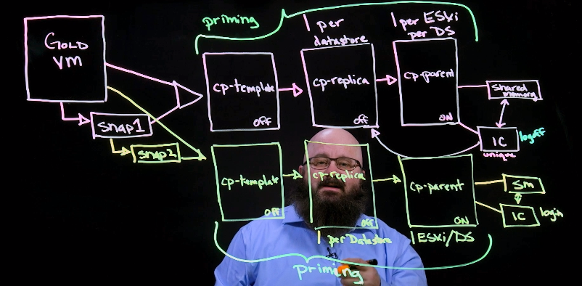

Differences Between Linked vs Instant Clones

- CBRC= Content Based Read Cache - a check that every memory block is accurate and consistent. Instant clones perform this only replica. Linked clones do it for every VM (slower).
- No database required! View Composer needs a DB, Linked clones do not.

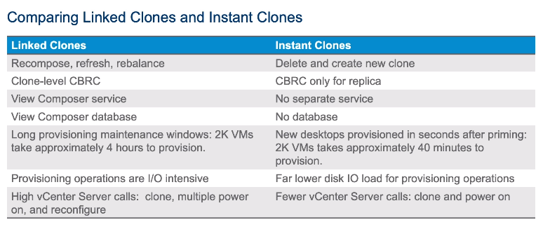

Transparent Page Sharing Scope – Automatically enabled – but can be a security risk in obscure configurations – allows VM’s on the same hosts to page-share common OS data.

Storage Accelerator – Automatically enabled

Much less load on vCenter with Instant Clones.
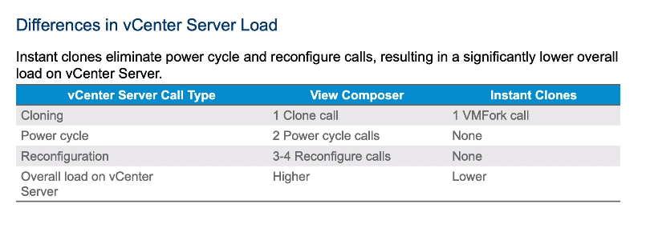
Limitations of Instant Clones:
- Only single-user desktops are supported. RDS hosts are not supported.
- Only floating user assignment is supported. Users are assigned random desktops from the pool.
- Instant-clone desktops cannot have persistent disks. Users can use VMware App Volumes to store persistent data. For more information about App Volumes, see https://www.vmware.com/products/appvolumes.
- Virtual Volumes and VAAI (vStorage APIs for Array Integration) native NFS snapshots are not supported.
- Sysprep is not available for desktop customization.
- Windows 7 and Windows 10 are supported but not Windows 8 or Windows 8.1.
- PowerCLI is not supported.
- Local datastores are not supported.
- IPv6 is not supported.
- Persona Management is not available.
- 3D rendering is not available.
- You cannot specify a minimum number of ready (provisioned) machines during instant-clone maintenance operations. This feature is not needed because the high speed of creating instant clones means that some desktops are always available even during maintenance operations.

Troubleshooting Instant Clones
3 Steps:
Run these scripts from the connection server, within the folder dir prog files\vmare…\server\tools
- icMaint.cmd – deletes the parent VM’s from ESXi host so the parent VM cannot create more instant clones whilst maintenance is undertaken. The ESXi host then must be manually put into maint mode

- icUnprotect.cmd- Unprotects the folders and VMs that ClonePrep creates, so they can be edited.

- Set InstantClone.Maintenance setting on ESXi host to 1 before entering maintenance mode to delete instant clone parent VM’s.

- Use Recover feature to rebuild the clone

Instant Clone Provisioning Errors

Error: SERVER_FAULT_FATAL - Runtime error: Method called after shutdown was initiated OR Image publish fail

Solution: Disable, re- enable provisioning. Or re-push the image to the pool.

13 Creating RDS Desktop and Application Pools
• Explain the difference between an RDS desktop pool and an automated pool
• Access a single application by using the RDS application pool
• Compare and contrast an RDSH pool, a farm, and an application pool
• Create an RDS desktop pool and an application pool
Objective 2.2 - Build and Customize RDSH Server and Desktop Images

Requirements:
- Horizon Client
- RDSH servers
  - With RDS licensing role
  - With RDS desktop session host role
- Horizon Agent installed on RDSH server
- Connection server, AD and vCenter.
- Supports Blast and PCoIP

RDSH Key Components:
- It’s a server desktop (08, 2012, 2016 etc), not a Window OS desktop
- If there’s an existing session on Farm A for an app, and user selects App B which is also hosted on Farm A – then the pre-existing session will be used. Prevents license wastage.
RDSH Application pool:
- Entitled applications hosted by the RDSH farm/hosts.

Manual Farm = pre-existing RDSH servers
Automated Farm = uses Linked Clone or Instant Clone to create RDSH hosts

- Farms i.e. multiple RDSH server provide redundancy, scalability and load balancing

What can you do with an RDSH pool?
- Host multiple applications or an RDS desktop via the horizon client
- Publish apps to Horizon desktop pools
- Use Workspace ONE to distribute RDSH-hosted apps

Workspace ONE Integration
The following can be added to Workspace ONE:
- ThinApp Packages
- Citrix Xenapp apps
- Saas and cloud-based apps
- Natively installed apps
- Hosted apps (remote apps)

RDS Desktops:
- RDS host with the lowest number of sessions receives the next request
- Supports RDP, PCoIP, Blast or HTML access.
- Persona not supported by RDS desktops.

Linked-Clone RDS Farm:
Points to note/Requirements/Preparation:

- Remember to select ‘View Composer Agent’ during Horizon Agent install on the RDS box (instead of Instant Clone)
- Recompose operations will create a new, unique SID for each linked clone.
- Configure licensing on the Master before cloning it.
- Disable WSUS before taking snapshot.
- Refresh and Rebalance are not available!

Instant Clones RDS Farm
Requirements:
- Virtual hardware v11 or greater
- vSphere 6.0u1b or above
- VMXNET3
- Server 08 R2,2012, 2016
- View conn. 7.1 + and Horizon Agent 7.1 +
- Static Binding port group

RDSH Immediate Maintenance:
- Old RD session hosts are deleted and recreated.
- A minimum number of RD hosts are kept alive during immediate maintenance to avoid downtime for users.
RDSH Recurring Maintenance
- Again, minimum number of hosts remain online
- Used for regular scheduled refresh of desktops

• Identify the load-balancing options for Remote Desktop Session Hosts
Load Balancing Methods for RDS Hosts:
- Default is to use quantity of active sessions on a host to determine where to place the incoming connection.
VMware Scripts! A Better way to do it:
- VMware scripts that poll PerfMon for load based values and creates a load preference value 0-3 which it relays to the View Connection server. Below scripts must be installed n all RDS hosts.
  - Memoryutilisation.vbs
  - Cpuutilisation.vbs
- 0=Block new session connections, 1=Low preference/high load, 2= Med pref/norm load, 3=High pre/low load (accept sessions)
- Secondary, multiple session will always go to the Pre-existing session even the server score is 0.
- Anti affinity rules might be in place to block new sessions

You can query the report on the Horizon Dashboard > System Health to see status against each RDS host and its server load based on the exit codes above:
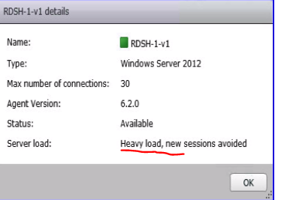

How to configure:
- Must enable
  - VMware Horizon View Script Host Service (Services.msc)
  - Enable a registry key on the RDS host so the agent is aware of it.
    - HKLM\Software\VMware….\ScriptEvents\RDSHLoad\cpu (key name)

Application Anti Affinity Explained:
- Heavy load apps (autocad) – you might not want more than 2 instances running on any given host in a farm. The connection will be blocked for new sessions only upon connection.
- Additional sessions that will redirect to a pre-existing sessions ignore any app anti affinity rules.

10 VMware Horizon Authentication
• Compare the authentication options that View Connection Server supports
• Explain the purpose of roles and privileges in VMware Horizon
• Configure Horizon Server to use a new TLS Certificate

Section 4 - Configure and Manage Identity Manager

Objective 4.1 - Install and Configure VMware Identity Manager

ESXi requirements: 5.0 U2 +, 5.1, 5.5 or 6.0+
Format: OVA
Hardware:
- 2vCPU, 6gb
Database requirements:
- Internal Postgres provides up to 1k users. Can be linked to external SQL (should be in prod setup)
- Windows or SQL authentication

Install status: can be standalone or cluster of 3 nodes
Requirements: Anything over 1k users needs 3 node-LB cluster.

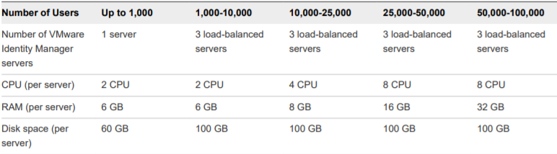

Prerequisite apps for Identity Manager (included in installer):
Java
Erlang
RabbitMQ
AD module for Powershell

- Create A records prior to install, reverse lookup is optional
- If you do not use a load balancer or reverse proxy, you cannot expand the number of VMware Identity Manager machines later!
SSL:You must install identity manager root ca in the load balancer in order to install ssl certificate ,otherwise ssl won’t work and external devices won’t work
Vice versa, you must copy load balancer root certificate to the identity mgr server too
Redundancy To create redundancy, after installing the first ID manager node, run a script to create an ENC file which contains the configuration of the first node, to duplicate it
Scaling Out Before you create a copy of the first instance, you must configure the first node behind a load balancer and change its Fully Qualified Domain Name (FQDN) to match the load balancer FQDN. Also, complete the directory configuration in the VMware Identity Manager service before you create the ENC file.

Horizon Integration:
Provides access to ;
- Thin App
- SaaS apps
- View Horizon Desktops (Horizon Air or On prem inc RDSH apps)
- Citrix XenApp (Requires Citrix Receiver app on client device, distinguishedName is a required attribute in the app directory).
- Citrix XenDesktop (Citrix Receiver app on client device)
- Horizon Cloud on Azure
Joining vIDM to AD to allow access to Horizon View Pods and Resources

- Ensure userPrincipalName is setup as a user attribute
- Identity & Access Management > Setup > Connectors > Join AD Domain
Accessing View Resources- 2 methods:
- User-activated (recommended): VIDM adds resources to the users catalog page, users must move resource from catalog to Launcher page.
- Automatic: VIDM adds resources directly to launcher page
Configuring Access to ThinApp Resources
- Modify the relink –h command in the thinapp package to allow vIDM to manage them.
- Packages must be in MSI format
- Stored on Windows network share in an AD domain accessible by the connection server, and have NTFS Read&Execute rights for users, and Read Share permissions,
- UNC paths accessible to users/vIDM too
- Read access to the built in Domain Computers group and Domain Controller group

Configuring Citrix Resources
- Citrix Receiver required on client machines
- Integration Broker v2.6 or later
  - Installs onto: Server 08 R2, 2012, 2012 R2

What roles can entitle applications and modify entitlements?
- Super admin
- Or a custom role that includes: Manage Entitlements, Manage Web Applications, Manage App Sources, Manage Third-Party Apps

Integrating Services into vIDM, Access Policies etc

For Horizon Desktops/Apps:
- Join VIDM to AD domain: Setup > Connectors . Join Domain
- Create a virtual app in Catalog > Virtual Apps – configure these apps to point to Horizon resources

Access Policies:
Create Access Policies: Catalog > Virtual Apps > Access Policies:
These policies use a culmination of options:
- NETWORK RANGES: Identity & Access Mgmt > Policies > Network Ranges: set the internal/external URL/trusted network ranges to allow access in.
- DEVICE TYPE
- USER GROUPS MEMBERSHIPS : either AD group, or local VIDM security group
- Authentication Method – has user auth’ed with SAML, RSA, RADIUS etc
- Session duration: i.e. how long before re-auth needs to happen
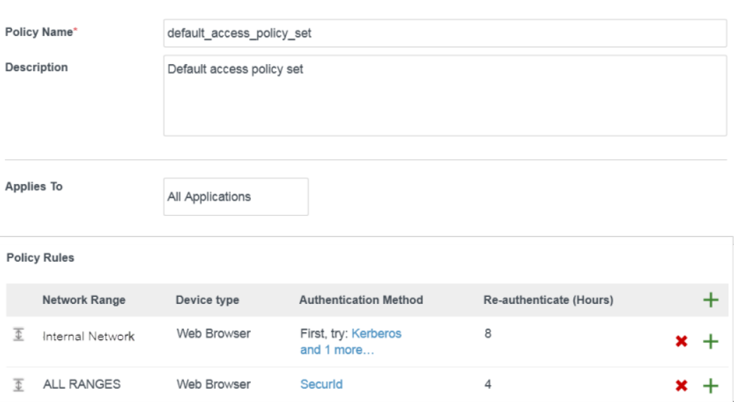
Objective 4.2 - Manage VMware Identity Manager

Troubleshooting VIDM Issues

Unable to launch View Desktop or App
Cause: Expired SAML metadata after last sync
Solution: Resync the resources: Catalog> Manage Desktops Apps > View Applications > Pods and Sync > Sync Now

Unable to synchronise View Resources
Cause: /etc/krb5.conf file contains incorrect domain info
Solution: Edit domain_krb.properties and add View domains to it
Edit krb5.conf file Realms section.

Section 5 - Configure and Manage User Environment Manager
12 Profile Management Using User Environment Manager
Objective 5.1 - Install and Configure VMware User Environment Manager
User Environment Manager aka Dynamic Environment Manager (2020)
Components:
- UEM Management Console
- Flexengine and service installed on desktop
- Shares with permissions for end users to create folders and RW to
- GPO in place with loopback processing to run Flexengine –s on boot
- Optional: UEM Self-Support and Application Migration

• Install User Environment Manager
Installer Components:
- Flexengine
- App Migration
- Self Support
- Management Console

Supported OS:
Win 10, Win 7, Win 8.1
Win Server 08 R2,2016,2019

• Outline the steps that are required to install and configure User Environment Manager components
Installing – High Level
Created a new NTFS folder for the UEM config and set the NTFS permissions
- administrators – FullControl,
- Users ‘Create subfolders and contents only’,
- CREATOR OWNER ‘Subfolder and files only’)
- We then install and point the mgmt console to the new share, then …
- Used easy start feature to configure common app templates.

ADMX GPO Templates
- Copied all the ADMX files into sysvol\sysvol\Policies\PolicyDefinitions root folder
- Copied all ADML files from the en-us folder into sysvol\sysvol\Policies\PolicyDefinitions\en-us
- Best practice: Always wait for the network at computer startup
- Necessary: Set Loopback processing – Replace
- Necessary: Run FlexEngine as Group Policy Extension– this ensures flexengine runs at logon. Optionally, it can be ran as a logon script, but not recommended.
- Flexengine –r runs at logon (-r = READ the config)
- Set a logoff script to run flexengine –s (-s STORE/WRITE to the profile)
- That’s it!

NoAD Mode:
- Ignores all GPO settings, logon/logoff scripts and any other UEM settings provided by GPO.
- Uses an .xml config file that sits on a share (see below) and you install the agent on your endpoints to point to it.
- You can also configure the settings in the xml file from a central store
Agent:
- Install the UEM agent into VM’s/RDSH servers using .msi cmd line pointing the config
- msiexec.exe /i "<installer-file>" /qn /l* InstallUEM.log NOADCONFIGFILEPATH=\\<config-share>\General

Objective 5.2 - Manage VMware User Environment Manager
• Identify the User Environment Manager functional areas and their benefits
• Manage user personalization using the User Environment Manager management console
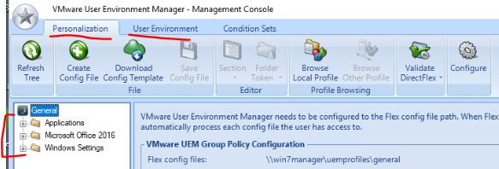

Extra features that might get mentioned in the exam:
- Download Config Temple = log into vmware online and download templates
- Import ADMX-based settings in ‘User Environment’
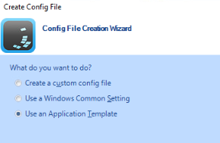
Custom config = blank

Windows common = Native settings- IE 11, regional settings, taskbar (native OS stuff)

App template = Native MS Apps - MS Word, Excel, Outlook , Adobe

GPO template files are intuitively named…
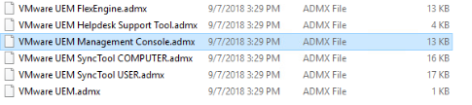

UEM settings I don’t know about:
Application Migration – for merging settings from old to new app versions.

Application Blocking:
Evaluation in this order:
- Hash based rules
- Path based rules
- Publisher rules

Privilege Elevation
- Can’t elevate .msi files, only .exe can have priv elevation applies.

• Describe User Environment Manager smart policies
Horizon Smart Policies
Requirements:
- UEM v9.0 +
- Only available on PCoIP or Blast sessions
Available settings:
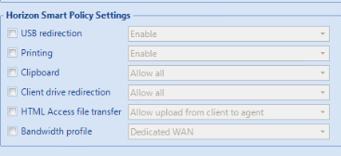
USB, Printing, Clipboard, CDR, HTML FTP, BW
-Bandwidth profiles can be scoped to UAG connections/gateways where the session originates from
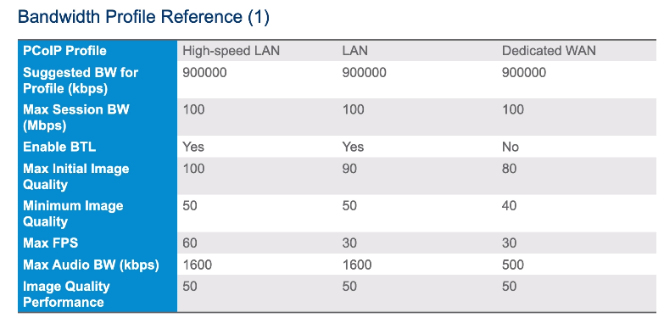

Triggered Tasks
- Refresh UEM, re-apply DirectFlex at session disconnect/reconnect , workstation locl/unlock, appstack attach completion

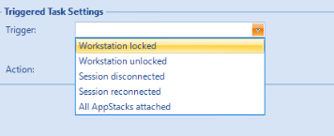
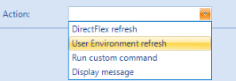

Applying smart policies to Multiple Sessions (i.e. RDSH app users with multiple application sessions on the same host)
- Add this to logon/logoff script: -HorizonMultiSession –r or –s for logoff

Upgrading UEM
To upgrade User Environment Manager, you must upgrade:
- FlexEngine,
- Management Console
- then ADMX templates in the given order.

UEM Command Line Arguments;

Run FlexEngine as Group Policy Extension

UEM Helpdesk Tools
What can it do:
- Restore profile archives (or multiple archives)
- Search for users
- Reset (wipe current settings)
- View FlexEngine Logs

Section 6 - Configure and Manage App Volumes
Objective 6.1 - Install and Configure VMware App Volumes

• Explain how App Volumes works
- Layers either VMDK or VHD files containing the apps seamlessly into a desktop
- AppVols agent merges the appstacks into the native OS registry, filesystem etc via a filter driver.

• Identify the features and benefits of App Volumes
- App lifecycle management (upgrade, remove, layer multiple apps in a package)
- Real time Seamless delivery
- Central management, persistent user experience in non persistent environment

• Install and configure App Volumes
Requirements
AppVols manager uses SQL server express or an external dB
Requirements:
SQL Server 2008 R2 (express, standard, enterprise, datacenter)
SQL Server 2012 SP1 , SP2 or SP3 (express/s/e/d)
SQL Server 2014 SP1 and SP2
SQL Server 2016 SP2
2vCPU
4gb
.Net 3.5
Domain Functional Level: 2003 or above
- 15 Appstacks attached max for appvols per desktops

Operating Modes for App Vols:
VMDK Direct Attach Operations – stored as VMDK’s within a hypervisor datastore and attached to the VM using standard functionality.

VHD In-Guest Operation Mode:
Stored on CIFS shares as VHD and attached to the target using operating system functionality

Types of Hypervisor Connections:
VMware vCenter Server: ‘Normal’ method for mid-large deployments, uses VMDK direct attach and can assign vols to VM’s running on multiple hypervisor hosts

Singe ESXi Host: for POCs/tiny deployments – uses VMDK direct, and assigns from a single ESXi host.

VHD In Guest Service: can be assigned to physical machines or via third party hypervisors, uses the In-Guest operation mode.

Writable Volumes:
3 Flavours:
- Profile settings and user installed apps
- Profile settings only
- Installed apps only

Considerations For Writable Volumes

- You may need to backup your writable volumes (admin overhead)
- Try to avoid using encryption on writable volumes
Support for physical endpoints and writable volumes is only given under the following constraints:

- VHD In-Guest mode is the only supported machine manager mode
- Constant network connection is required
- Automatic Windows update should be disabled
- Any update to the OS should not be performed with writable volumes detached
- Detach writable volumes when performing a user log out. Profiles in the writable volume might be corrupted and on next login cause the profile to be recreated.
- All volumes should be detached when performing any revert, recompose, or refresh of the virtual machines.
Check the advanced appvol actions for settings that might enable/disable elements of writable disks or appvols
Load balancing appvol managers
- install 2nd appvol manager as normal and point to the same SQL dB, you can then put this behind a hardware load balancer and point the appvol Agent to the FQDN of the load balancer.

Objective 6.2 - Manage VMware AppStacks and writeable Volumes

Upgrading AppVolumes:
Can’t perform in place upgrades, you have to uninstall the current appvol manager (server) + agent (vm) then install the new one, taking backups of your dB and snapshot of existing servers

14 Using App Volumes to Provision and Manage Applications
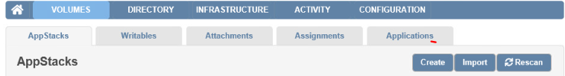

View a global catalogue of all apps under Volumes > Applications

Conflicts with App Assignments:
- If an appstack is assigned to a user and a computer simultaneously, the computer assignments wins.
- Users that have user-assigned appstacks and writeable volumes assigned, both will attach

Drive Letters:
- AppStacks does not assign drive letter
- Writeable volumes does assign, but hides it

Writeable Volumes
- Can be assigned to users, groups or computers.

Appstacks, AD Sync and Troubleshooting
User ‘override precedence; to give say, adobe v9 precedence in the os over v10, on a desktop a file will open with 9 before 10
AD sync happens every hour, unless manually invoked

Create App Template:
- Create a new VM w/ a thin provisioned disk attached (sized to your template requirement). Attach the current template to your VM (browse to /cloudvolumes/apps_templates/ ).
- Boot up, use disk manager to format and create simple volume on your newly attached VMDK.
- Set the view to Unhide hidden items/protected system files, and then copy the contents of the ‘old’ template into the new one (all the BAT files etc).
- Detach both disks. Then via Web client > browse datastore and copy the template.vmdk file from the virtual machine folder to > /apps_templates/ .

Log files and system logs for AppVolumes
- Pending Actions - Displays a list of actions waiting to be performed. The actions are processed in the background and are completed in the order they are submitted. Select the Auto Refresh box to automatically show the latest list of actions.
- Activity Log - Displays information about user logins, computer power-ups, and volume attachments. System messages include messages and errors generated from internal events such as polling for domain controllers, Active Directory access, and so on.
- System Messages - Displays messages and errors generated from internal events such as volume attachment, Active Directory access, and so on.
- Server Log - Shows the end of the current log file with the option to refresh in real-time. Click Play to view the log in real-time.
- Troubleshooting Archives - Archive and manage configuration settings and logs. You can create, download, and delete the archives.

15 JMP and Horizon 7 Overview
• Identify the benefits of JMP
• Enlist the JMP and Horizon 7 components
• Identify JMP deployment considerations
• Install and configure JMP Server
JMP Server
- Provides a platform for managing the horizon environment (Instant clones, UEM, AppVols, RDSH) and is suited to bigger deployments (1000+ users)…
- A single console to define and manage desktop workspaces for users and groups ofusers

Once it’s installed, point the JMP server to each component of JMP workflow i.e. you link it to AppVols manager, UEM config shares, Instant Clones

Software Requirements:
Windows Server
SQL db (TLS certs optional)

JMP Requirements:
AppVols 2.14 +
UEM 9.2.1 +
VIDM 2.9.2
Horizon 7.5 or above

Section 7 - Configure vRealize Operations for Horizon
Objective 7.1 - Install and Configure the adapter instance and Horizon Broker Agent

Components of vRops:
- Horizon Adapter > this runs on the master node /vrops manager instnae, or a remote connector node (if multi-site) .
  - Horizon adapters collect inventory info from the broker agents (connection servers) and performance metrics from the desktop agents, passing this info to the vROPs manager.

- Broker Agent: > are a windows service that run on connection server for a given POD , it collects inventory data and forwards it to the Horizon Adapter
  - Each POD can only contain 1 broker agent!
  - Broker agent required .NET 4.6.2
- Use the Broker Agent Config Utility for Horizon to configure it
  - Port 3091
  - Point to FQDN of vROPS manager node
- Broker agent MUST connect to your events database.

Desktop Agent:
- Desktop Agent> installs as part of Horizon Agent

Installation process, requirements for vROPS
- 4CPU and 16gb vRAM required
- Horizon 7.3 -7.10 required
- Online or offline installation available – online will download the OVA package, offline can point it to the package

Log File Locations
Broker agent: C:\ProgramData\VMware\vRealize Operations for Horizon\Broker Agent\logs

Desktop agent: C:\ProgramData\VMware\vRealize Operations for Horizon\Desktop Agent\logs

- Install vROPs OVA appliance
  - Verify the vCenter Adapter instance is configure for each vCenter Server. vCenter adapter is included in vROPs
  - Check FQDN’s for vCenter Adapter all work (i.e the adapter can use FQDN)
  - Sync all the time to NTP server
  - License vROPS (eval = 60 days)

vROPS for Horizon Configuration (High level)
- Install vRops for Horizon Manager (PAK file)
- Create a Horizon Adapter instance (on the vROPS master node)
- Add License key
- Associate Horizon objects with the license key (i.e. tell it to collect data from all pools, all vms)
- Install Horizon Broker Agent on the connection server (1 per pod)
- Configure Broker Agent
  - Point it to vROPS manager node over TCP 3091
  - Point it to Horizon Events Db
  - Point it to UAG or Appvols Managers
- Install vROPS Desktop Agent (part of Horizon Agent install) onto master images.

Import vGPU Dashboards
- Dashboards > Actions > Manage Dashboards >Configure > Import Dashboards
  - Import the file: Horizon End User Experience With vGPU.json

Troubleshooting vROPS issues

Unable to pair broker agent with Horizon adapter
Cause: Incorrect firewall rules
Solution:Allow the following (on the vRops appliance ) by editing vmware-vcops-firewall.conf file and reboot it aka check firewall rules and restart the Broker agent.

Broker agent needs TCP 3091 open to communicate by default. The ranges below cover all other services that talk to the broker.
TCP:3091-3095
TCP 3099:3101

Broker agent fails to pair with connection server
Cause: locked.properties file contains a value for connection server of ‘localhost’ – so the install isn’t using IP of conn. Server.
Solution: backup and remove the file from install_directory\VMware\VMware View\Server\sslgateway\conflocked.properties, reboot conn server and retry.

Logon duration missing on dashboard
- Solution:
  - Sync all broker agents, desktop agents and event dbs to an NTP source
  - Reboot broker agent service

Dashboards appear blank after upgrading from earlier version of vROPS
Cause: Viewing the legacy environment on your browser.
Solution: Browser cache needs clearing

Dashboards display “No Data” in vROPS
Cause: The objects being filtered in the dash didn’t exist when the dash was created.
Solution: Edit and Save each widget to refresh the dashboard Dashboards > Edit Widget > Save

