15% 1.0 Endpoint Threat Analysis and Computer Forensics
1.1 Interpret the output report of a malware analysis tool such as AMP Threat Grid and Cuckoo Sandbox
1.2 Describe these terms as they are defined in the CVSS 3.0:

- CVSS has 3 scoring metrics, base scoring is mandatory.(0-10) and is maintained by FIRST.
  - Base Score - intrinsic characteristics that don’t change over time, most important and mandatory to be able to score a vulnerability.
    - Exploitability - 5 scores: AV,AC,PR,UI,Scope
Attack Vector: Physical, Local, adjacent (Bluetooth!), remote (the best).
Attack Complexity: Low, High
Privileges Required: None, Low (local), High (admin)
User interaction: None, Required
Scope: Unchanged, Changed
    - Impact - 3 scores against: N/L/H Confidentiality, Integrity, Availability.
    - Opposite of CIA is Disclosure, Alteration, Destruction…
OPTIONAL
Temporal – assesses how the vulnerability changes over time.
    - 3 Scores– Exploit code maturity, Remediation Level,Reporting Confidence. X/High (xploit readily available and automated)/Functional (functional code exists and is available)/Proof-of-Concept (exploit code is available not requires skilled hacker to execute) / Unproved (nothing available/theoretical exploit)
Environmental – characteristics of the vulnerability within the organization’s environment.
- Security Requirements and Modified Base Metrics
THESE SCORE AS X/L/M/H.

CVSS Scores(remember the scoring as high to low -1,2,3,3) ex. 0-4(4),4-7(3),7-9(2).9-10(1)
Vector Strings: ‘Preferred’ ordering:
CVSS3.0\AV:P\AC:L\PR:N\UI:R\S:C
Low 0.1-3.9 Non-preferred ordering (i.e. order is irrelevant)
Medium 4.0-6.9 CVSS3.0\S:U\AC:L\AV:N\C:H\I:H
High 7.0-8.9
Critical 9.0-10

1.2.a Attack vector – Physical (access to a physical component), Local (login locally), Adjacent (Think: Bluetooth, WLAN), Remote (the more remote, the better).
A segment of the pathway an attack uses to access a vulnerability.
Sum of attack vectors = attack surface
A theoretical vulnerability = an existing vulnerability that an attacker does not know yet.
To discover the attack surface of a system you should analyse the source code and list the points of vulnerability i.e. UI forms, Runtime processes, local storage, Files, Database/e-mail features.
You can then categorise these points of attack – Admin interfaces, Business Workflows, Data Entry (CRUD forms) and so on.
Exploitability scanners: can expedite this process i.e. nmap (Network scanner), Nessus, nexpose , Qualys
Web application scanners like OWASP_zed_attack , Skipfish, Arachni. Remember OWASP is a non-profit organization to promote best practice in Web app development, they have a threat model framework and are not a compliance framework. The exam offers OWASP as an example of a compliance framework…
1.2.b Attack complexity - Low/Hight
What conditions beyond the attackers control need to be in place in order for a vulnerability to be exploited. Low= bad, attacks can be repeatable and easily executed. High=good, attack relies on conditions that are beyond the attackers control.
1.2.c Privileges required – None/Low/High: what privs are required to execute the attack?
1.2.d User interaction – NR/R - is user interaction needed to perform an attack?
1.2.e Scope –(changed/unchanged) U/C (of the attack…) - How the attack affects resources beyond the attacker’s privilege level.

1.3 Describe these terms as they are defined in the CVSS 3.0
1.3.a Confidentiality –N/L/H - limiting info access and disclosure to only those who are authorised and preventing those who are not.
Confidentiality (privacy) extends to data, systems and processes and can be preserved by:
- Logical and physical controls
-Encryption
-Database views
-Controlled traffic routing

1.3.b Integrity – N/L/H - the trustworthiness and veracity of information
Integrity also applies to devices, hardware and software. Compromised devices have their integrity violated.
1.3.c Availability - Loss of availability of a device/serve (think DDoS) – N/L/H - data and systems should always be available.
ONLY THE ENVIRONMENTAL SCORES USE X/L/M/H score ranking (not defined, low/medium/high).
1.4 Define these items as they pertain to the Microsoft Windows file system
1.4.a FAT32 – FAT16, exFAT – early partition use and used for boot devices. Contains: boot sector, jump code, sector size, FAT table. FA32 max is 2tb
1.4.b NTFS – default windows file system. Contains a boot sector, sector size, reserved sectors etc and the MFT (master file table) which contains metadata for all the files stored on it. System also enabled timestamping and permissions/ACL’s (at OS level).
1.4.c Alternative data streams – aka ADS a.k.a Multiple data streams – provides support for apple Mac HFS (hierarchal file system).
Alternate Data Streams (ADS), Files are stored as attributes, one attribute is $DATA which represents the actual data of the file, NTFS allows additional data to be part of the $DATA attribute that applications can use, ADS data is not displayed by DIR command alone, must use /r option, ADS can be used to hide malicious code in files
1.4.d MACE
NTFS keeps track of lots of time stamps. Each file has a time stamp for 'Create', 'Modify', 'Access', and 'Entry Modified'. The latter refers to the time when the MFT entry itself was modified. These four values are commonly abbreviated as the 'MACE' values. (Modified, Accessed, Created, Entry) = MACE
1.4.e EFI – Is a system partition used for interacting with UEFI (universal extensible firmware interface) for loading drivers/system files etc @ boot.
1.4.f Free space – memory management is either static or dynamic. Heap=runtime, stack=compile
VirtualAlloc – OS virtual memory allocation
HeapAlloc – allocates any size of memory requested
Malloc = C++ library functions – allocated for runtime of code.
1.4.g Timestamps on a file system
MACE values (modify, access, create and entry modified) are timestamp values and NTFS uses ADS (alternate data streams) to support Apple mac OS.
1.5 Define these terms as they pertain to the Linux file system
Linux – command to view processes: top or htop
1.5.a EXT4 – Linux file system that uses journaling. Supports up to 1 exabyte file size and up to (1024 gigabytes) HDD capacities i.e. 1 terabyte.
1.5.b Journaling – Journaling uses overhead, the EXT4 file system is for Linux and journaling can help repair inconsistencies as result of bad shutdowns.
2 1.5.c MBR – LILO and GRUB - master boot record, 512 or more bytes, partition that contains instructions for where OS is stored and the partition table.
1.5.d Swap file system – is used for transitional data, it’s slower than RAM and prevents the OS from crashing (think Pagefile for windows). It is generally 2x the RAM allocation of a machine and most data passed through the swap space in the OS. Remember, swap space, RAM data should be the first things collected during a forensic investigation.

1.5.e MAC
Mandatory access control i.e. ACLs against NTFS files provide MAC control.
1.6 Compare and contrast three types of evidence
Evidence can be used to support cases of Extortion, Domestic violence, fraud/money laundering, drug crime, murder, sabotage, terrorism.
A ‘reasonableness’ test should be applied to the quantity of digital evidence that is collected; log files etc contain vast quantities of data, so parsing these is important and clarifying what is/isn’t evidential.
Chain of custody – how was it collected, who handled it, how was it stored/tracked, who had access to it, who stays with the evidence during transportation i.e. Evidence preservation. Also use ESD (electro-static-discharge)
1.6.a Best evidence – original form evidence or ‘physical copy’ of a machine. This can be done using:
Forensic Methods for collecting data from devices:

- write blocker – which takes block-level copy of data.
- Data carving, file carving involves recovering deleted files using metadata and is a forensic process for data recovery
- Saves it as .AFF, .ASB,. VMDK, .DD, .RAW
- Only effective if the media is stored correctly and includes free disk space and deleted space – it must be a sound copy, bit for bit. A logical copy is not good – only copies user-centric data and ignores system partitions , deleted data, RAM etc.
File carving is used to piece together files that may be fragmented from unallocated space, this is known as data carving.
Best Practice:
Always work from a copy of the best evidence.
Transporting evidence:
In a faraday cage is ideal (anti static cage that prevent electronic comms -wifi/Bluetooth etc). Remember, evidence should not make physical contact with other items.
1.6.b Corroborative evidence
Evidence that confirms a proposition in a case. IPD/IDS alerts might be corroborative (because they support the theory there has been an attack, but could also be false positive, and therefore not legitimate ‘best’ evidence). An actual malware extracted from a server is best evidence.
1.6.c Indirect evidence
Is circumstantial, things like DNA, fingerprints – they rely on extrapolation to a conclusion of fact. Property owned by someone else can be considered as indirect evidence (i.e. an object )
1.7 Compare and contrast two types of image
1.7.a Altered disk image = hashing of data collected for evidence will prove it’s untampered. Altered images will produce a different hash.
1.7.b Unaltered disk image will have the same SHA-1 (note, MD5 is not recommended for hashing, it’s legacy and cracked, exam may mention md5) value as the original. A bit-for-bit copy of a disk (or mirror copy) is the best method for ensuring evidence can be presented and used and the original can be stored or returned to the owner.
1.8 Describe the role of attribution in an investigation
Investigations can be Public (settled in court), Private (corporate) or Individual (ediscovery) – eDiscovery is the process of obtaining electronic evidence (video/audio, files, data etc) as a response to a request for data in a law suit.
Systems and networks aren’t designed for extraction of digital evidence so it’s important to take an evidence-led approach and not a suspect-led approach. Forensic evidence tools often miss the less-obvious evidence in favour of identifying easily-found factors. Chain of custody ties into this too- what is collected, how, where is it stored etc.
What type of logs help with attribution of an security event?
DHCP, 802.1X and VPN logs all help to identify threat actors, although DHCP can be difficult due to the turnover of IP addresses.
1.8.a Assets
In information security, computer security and network security, an asset is any data, device, or other component of the environment that supports information-related activities.
1.8.b Threat actor
Forensic tools can often look for the most obvious evidence and ignore the less obvious/hard to find traces. Cyber sec investigators also face difficulty in determining the reliability of endpoints/network devices/ servers in order to present evidence to attribute an asset to a threat actor.

22% 2.0 Network Intrusion Analysis
2.1 Interpret basic regular expressions
Regular expressions are used for parsing (searching) data in log files etc.
A great tutorial for learning RegEx
https://regexone.com/
Cheat Sheet:
. any char
\. match a period char
\d any digit 0-1
[abc] match a single a, b, or c - but nothing else. e.g [fbc]an would match Can, Ban, Fan
[^..] = Dont match (WHEN IN BRACKETS!) - example: [^T]oil would match Boil, Coil but not skipToil.
^word = do match the word
[0-6] would match a range, [A-Z] casesensitive a-z. \w matches any char (A-Z,a-z,0-9,_)including an underscore.
Quantifiers:
wa[z]{3,5}up matches wa, and then z (at least 3 times, no more than 5 times) and up.
Kleene Star and Kleene Plus aka At least's
aa+ will match at least 2x a's in a string aaaabcd. Whereas a would match 1xa. This could be aaa+ for 3'as
\d* would match any number of digits
Optional char:
? denotes optional char. Example, ab?c would match abc, or ac, because the b is considered optional. Again \? would be needed
if you wanted to match the literal ? char in a string.

White space:
\s matches any white space (carriage return, space bar, tab)

Grouping to isolate
Use ^(file.+)\.pdf$ to match a string - the ^ symbolises the start of the word, with $ the end. So this would match file_1234.pdf
Nested groups:
^(.{3}\s([0-9]{4})) would capture the date Jan 1987. Useful if you want to capture different sets of data in a string.
We're saying, any char (3x occurrences max), some white space, then 4 occurrences of any number 0-9.

\b word boundary.
To search for a word, use \d+\b this is any alphanumeric char (at least 1+letter) -to- the word boundary i.e the 'end' of the word.

2.2 Describe the fields in these protocol headers as they relate to intrusion analysis:
Protocol analysis is difficult to evade and inspects the expected header information of a packet.

2.2.a Ethernet frame
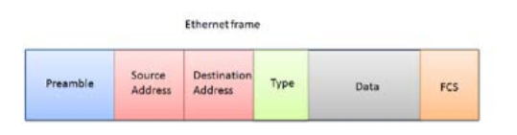
2.2.b IPv4
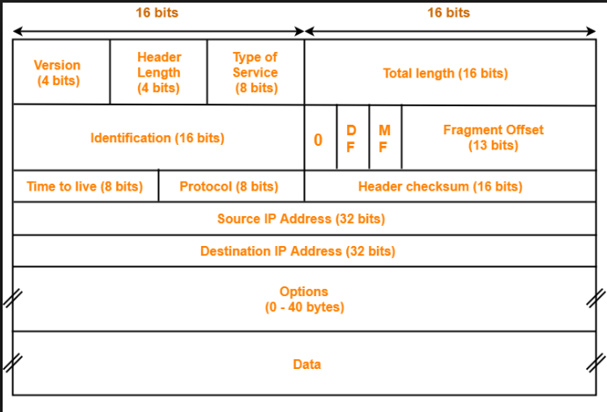
2.2.c IPv6
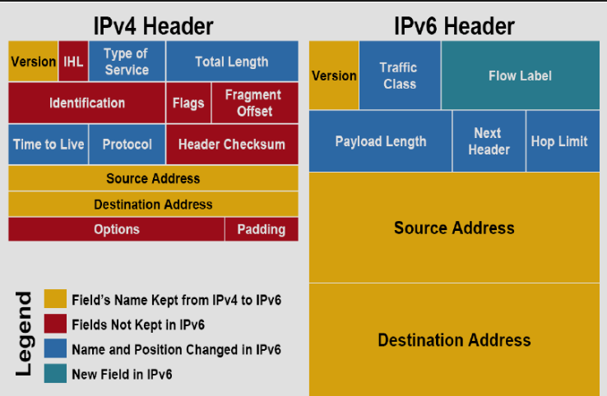
2.2.d TCP – the TCP protocol should consist of Seq number, Ack number, and ports (source and destination – which should be 22 for SSH, or 21 for FTP)- the TCP Segment Length= the number of bits.
22 for SSH
443 = SSL
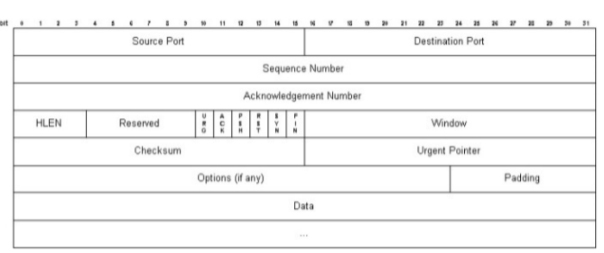
2.2.e UDP
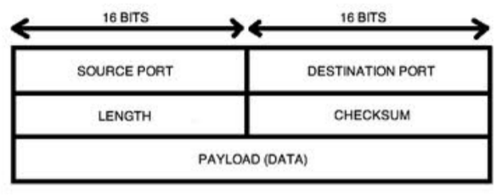
2.2.f ICMP
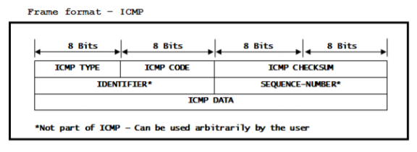

2.2.g HTTP – should show the GET request, the web server it’s sending the request to
Anything below HTTP 1.1 should be investigated. Also read around malicious user-agent strings:
Fields most commonly abused in HTTP headers:
- Header
- User-agent
- Cookie (look for the line USERID= or SESSIONID= - these fields are changed to allow an attacker to spoof a system as a different user)

SQL injection would show a Mozilla/5.0 {version/build} ‘ - the single quotation mark tries to run SQL script.

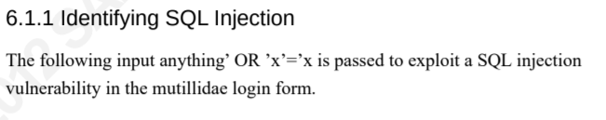

Read these!
https://www.sans.org/reading-room/whitepapers/malicious/paper/33874
https://www.vanimpe.eu/2016/10/21/proxy-server-logs-incident-response/
Identifying malicious HTTP requests:
https://www.sans.org/reading-room/whitepapers/detection/identify-malicious-http-requests-34067
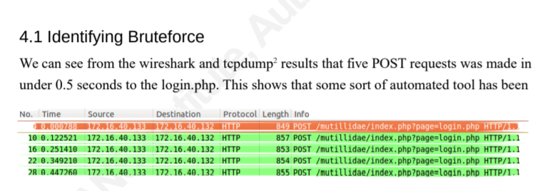
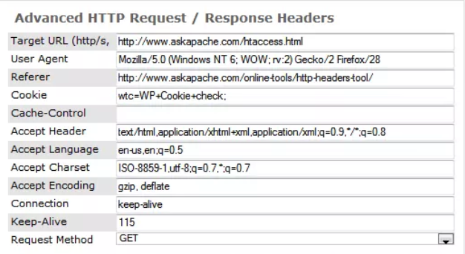
NGINX: writes to the error.log for intrusion/unusual events. The access.log retains data on user activity (who connects, when etc)
Most web browsers should use the user-agent string for content negotiation. Example, if an Opera browser requests content, the web server might deny it because it’s incompatible with that browser, this said, browsers use the user-agent string to impersonate other browsers (typically Mozilla) in order for the response from the web server to contain the requested content.
Legitimate example of a common user-agent string:
Mozilla/5.0 (iPad; U; CPU OS 3_2_1 like Mac OS X; en-us) AppleWebKit/531.21.10 (KHTML, like Gecko) Mobile/7B405

Malicious example (used by bots, with curl)
User-Agent: curl/7.21.3 (x86_64-unknown-linux-gnu) libcurl/7.21.3 OpenSSL/1.0.0c zlib/1.2.5

*EXAM TIP* - there will be a few questions around HTTP headers and you need to be able to identify a malicious vs legitimate user-user agent string. Be sure to read about Trident in a HTTP header.
https://webaim.org/blog/user-agent-string-history/

2.3 Identify the elements from a NetFlow v5 record from a security event
2.4 Identify these key elements in an intrusion from a given PCAP file
2.4.a Source address
2.4.b Destination address
2.4.c Source port
2.4.d Destination port
2.4.e Protocols
2.4.f Payloads

Remember to match port number to the type of protocol you think you are looking at in a PCAP file. Look for a response (if it’s a HTTP request) – is there one expected/what does this tell you? Which port is actually being used e.g. if you’re reading a HTTP request and the destination port is 443, the question might ask you if the port is 80 or SSL. The answer is SSL.

2.5 Extract files from a TCP stream when given a PCAP file and Wireshark
*EXAM TIP* The exam tests on common options in Wireshark (i.e. file > export option) and also how Wireshark filters are structured e.g. ip.addr == X.X.X.X or port eq etc. Be familiar with the syntax for creating filters in Wireshark.
Analyze > Follow > TCPStream
The format for filters in wireshark:
Ip.add == XXX.XXX.XXX.XXX
File > Export Objects > choose filetype (http, smb etc)
FILE > EXPORT PACKET DISSECTIONS
2.6 Interpret common artefact elements from an event to identify an alert
2.6.a IP address (source / destination)
2.6.b Client and Server Port Identity
2.6.c Process (file or registry) -
2.6.d System (API calls)
2.6.e Hashes
2.6.f URI / URL
2.7 Map the provided events to these source technologies

2.7.a NetFlow
ONLY v5 and v9 are in use today. Flexible Netflow is an extension of Netflow v9
Flows are unidirectional. A session consists of two flows—a server-to-client flow and a client-to-server flow.

Netflow is most useful during detection and analysis for:
- Network profiling and creating a baseline of what is ‘normal’
- Detecting compromised endpoints
- Detecting DDoS attacks
- Misconfigured firewalls
- Unusual user session duration (part of network profiling)
- Monitoring critical systems going offline…

Netflow involves using a NetFlow record, NetFlow collector and a NetFlow cache.
The cache can operate in different modes depending on how its implemented:

Normal: default cache type, records are removed or aged out based on timers.
Immediate: used for small flows, good for real time caching and DDoS detection
Permanent: no cache expiration, periodically exported.

Remember: Lancope Stealthwatch is Cisco’s IDS solution – it uses Netflow data to detect malicious activity.
IPFIX is beneficial because it’s vendor neutral and new features can be added to it without breaking the current implementations, it’s also backwards compatible.
Netflow records are usually exported with UDP. IPFIX uses SCTP.
Cisco Flexible Netflow:
- Used for tunnelling technologies where no IPv6 endpoint is available (i.e. 6to4, TUREDO, 6rd). Flexible NetFlow allows for multiple collectors of different data, for example –
Monitor 1------Monitor 2-------Monitors 3
Each monitor will have an Exporter configured to use a key field which defines what type of data is collected at L2 (e.g. MAC address, Source and dest IP, Protocol, ToS, TTL, flow number, Payload, DSCP) or L3 (Peer AS, ICG hop, forwarding state).
Non-key fields can include fields like Bytes long, bytes, packet, packets replicated – this type of data can be used for capacity planning.
Architecture of Flexible Netflow:
Flow Monitor – applied to the interface of network devices to collect the data and cache it.
Flow Exporters – attached to monitors, can be many-to-one, contain destination IP of reporting server and transport method (SCTP or UDP & IPFIX/NetFlow version)
Flow Sampler – configured on the router to throttle quantity of packets sampled. A performance trade off is typically between Sampler vs Router
Flow Records – contain flow data (Layer 2 to Layer 4).
Netflow can be installed on any Cisco device and Lancope is used on legacy/non-cisco devices that don’t support Netflow.
Open Source Netflow Analysis Tools: NFDump ,Logstash, ELK, Silk, Graylog
2.7.b IDS / IPS
Open Source IDS/IPS: SNORT
*EXAM TIP*
An IDS/IPS event will display a Signature ID (this is how you differentiate between IDS/IPS vs a Firewall log, for example).
Evasion techniques for IDS/IP=
https://medium.com/@IanBarwise/evasion-obfuscation-techniques-87c33429cee2
Fragmentation
Pattern change evasion
address spoofing
Low bandwidth attacks (TTL)
address proxy
encryption
2.7.c Firewall
2.7.d Network application control
2.7.e Proxy logs
Whitelist = Block everything, and allow the URL’s/objects on the whitelist.
Blacklist= Allow everything, and block the URL’s/objects on the blacklist.
A whitelist violation would be something that was blocked, but is on the whitelist. Which is the equivalent of a false positive.

2.7.f Antivirus

Cisco should really give examples of the type of logs per-device, but you should look for clues i.e. an AMP for Endpoints AV log would show an .exe or local file being scanned/quarantined, whereas a firewall log would show 5 tuple. A proxy log would have some whitelist/blacklist policy and/or URL reputation or DNS validation feature.

2.8 Compare and contrast impact and no impact for these items
2.8.a False Positive – When legitimate events are flagged as malicious – this is also dangerous. Benign trigger. False positives drain SOC resources.
2.8.b False Negative – dangerous, when a security event is not detected. High impact.
2.8.c True Positive – Correct behaviour when malicious event/alert is triggered and the event is legitimate.
2.8.d True Negative – Normal behaviour – the system is not alerting. Everything fine!
2.9 Interpret a provided intrusion event and host profile to calculate the impact flag generated by Firepower Management Center (FMC)

An impact flag can be configured to alert you to certain intrusion events, based on the severity assigned below:
Impact Level | Vulnerability | Color | Description
 | Unknown | gray | Neither the source nor the destination host is on a network that is monitored by network discovery.
 | Vulnerable | red | Either:  - the source or the destination host is in the network map, and a vulnerability is mapped to the host  - the source or destination host is potentially compromised by a virus, trojan, or other piece of malicious software
 | Potentially Vulnerable | orange | Either the source or the destination host is in the network map and one of the following is true:  - for port-oriented traffic, the port is running a server application protocol  - for non-port-oriented traffic, the host uses the protocol
 | Currently Not Vulnerable | yellow | Either the source or the destination host is in the network map and one of the following is true:  - for port-oriented traffic (for example, TCP or UDP), the port is not open  - for non-port-oriented traffic (for example, ICMP), the host does not use the protocol
 | Unknown Target | blue | Either the source or destination host is on a monitored network, but there is no entry for the host in the network map.

18% 3.0 Incident Response
3.1 Describe the elements that should be included in an incident response plan as stated in NIST.SP800-61 r2
Statement of management commitment
Purpose and objectives of the policy
Scope of the policy (whom and what does it apply and under what circumstances)
Definition of a computer security incident and related terms
Org structure and R & Rs, roles responsibilities and levels of authority for what an IRT can/can’t do, guidelines for external communications and info sharing and handoff escalation points.
Prioritization or severity ratings of incidents
Performance measures
Reporting and contact forms

Minimum of annual review.

3.2 Map elements to these steps of analysis based on the NIST.SP800-61 r2
3.2.a Preparation
- Picking an incident response team and structure (central, distributed, coordinating team/employees, partial outsourced, fully outsourced), war room, jump kit, buy forensic software, on-call, contact info etc.
- Configuring the IPS/IDS and installing the hardware/software in readiness for monitoring
- Risk Assessments
- Device hardening/Malware prevention/host security/network security. More details on this below..
- Creating user awareness training.
Preparing to handle incidents
AKA a Jump kit which contains everything required to deal with an incident. Typically an incident handler has 2 laptops – one standards (report writing/emailing) and one for investigative work (containing packet sniffers etc).
- Contact info (for all team members and outside contacts – law enforcement, agencies) and encryption keys/methods for verifying the identity of contacts.
- On call-info
- Incident reporting mechanism (forms, IM systems, anonymous submission system)
- Issue tracking system (ITSM)
- Smartphones (out of hours support)
- Encryption software (for comms between team members, deferral agencies etc during incidents)
- War room – for planning comms and coordination
- Secure storage – for sensitive materials
- Digital forensic workstation – for taking physical copies, images, log file preservation.
- Laptops
- Spare workstations – for sandboxing malware
- Portable printer/blank media/packet sniffers – for analysing infected workstations etc.
Risk assessments: Period assessments, identify the critical resources and emphasise the monitoring and response activities for those resources.
Host security: Hardening of host devices, patching and principles of least privilege, auditing enabled and monitoring of the configuration of machines.
Network security: Deny all activity that is not expressly permitted.
Malware prevention: Malware protection should be deployed at host (OS) , application (i.e email server, web proxies) and application client (email client, IM systems)
User awareness and training: policies and procedures using previous historic examples will improve awareness.

3.2.b Detection and analysis – THE MOST DIFFICULT PHASE!
High level: Precursors and indicators, prioritize the incident, it also entails how you prepare to be effective when an incident arises…
Incidents are challenging to detect due to the multitude of ways they can be detected (through AV, log analysers, IPS/IDS, manual processes, users reporting events), the volume of incidents/data to analyse and report on and the requirement of deep-specialised technical knowledge to properly identify an incident from said data.
Signs of an incident – Precursor (incident may occur in future) or an indicator (may have occurred or occurring)
Precursors: new exploit announcement, a threat from a group (hacktivist, state sponsored etc), log entries showing vulnerability scanner has been used.
Indicators: AV alerts showing infected hosts, sys admin spotting filename with unusual char. Deviations from typical traffic flows, high volume of bounced e-mails

This stage is about how you prepare to be effective during analysis – think of it as ‘ongoing technical preperation’
Effective Analysis steps:
Profile Networks and Systems – measure the expected traffic flows/activity to find average and peak usage patterns.
Understand normal behaviour – reviewing log entries to determine normal entries (using a parser, ideally). On-going review of what is normal in log entries can keep knowledge fresh.
Create log retention policy: align this with legal requirements and data retention policies for the company.
Event Correlation: For example, a firewall might log source/destination IP, but application log might show username/password, correlating these events is invaluable to determine if an incident occurred.
Synchronised host clocks: NTP everything for consistency.
Maintain knowledgebase: document pre-cursors, known behaviours, arch diagrams etc.
Use internet for research: For example, unusual TCP port numbers might provide hits about malware etc.
Use packet sniffers to collect additional data: from a network level
Filter data and seek assistance from others: Outside contractors or external resources can help determine cause of incidents.

Incident Prioritization
This is one of the most critical decision points in incident handling. The priority should be based on the following factors:
Functional impact of the incident: how will the incident impact the existing functionality of the affected system. What are the consequences if it’s not immediately contained?
Information impact of the incident: CIA triad – how does this affect the overall organization mission if there is a data breach.
Recoverability from the incidents: What is the effort necessary to recover from an incident and weigh this against the value the recovery effort will create, and any other requirement related to the handling.

Incident documentation:
Should include – a summary of the incident, current status, indicators, actions taken by all handlers, chain of custody evidence, comments, next steps to be taken, contact information for all parties.
Safeguarding incident data is also important – so as not to divulge a vulnerability that could be exploited elsewhere (disclosure to third parties/media should be reasonable/full/partial)

3.2.c Containment, Eradication, and Recovery
High level: Evidence Gathering, Identify the attacking hosts, Pick a containment strategy
Forensic Investigation Plan:
- How to collect the evidence
- How to safeguard the evidence
- The methodologies to collect and analyze the evidence
- Who will be responsible for carrying out forensics and analysis, respectively
- How to maintain and report the movement of evidence (chain of custody)
- It does not include any information on who to submit the evidence to as that will be defined by chain of custody or the court of law.
Creating a Containment Strategy:
Containment strategies will vary depending on the type of incident. Separate strategies should exist for each one, but the basic criteria should include:
- Potential damage to and theft of resources
- Need for evidence preservation
- Service availability (e.g. network connectivity, services provided to third parties)
- Time and resources needed to implement the strategy
- Effectiveness (full containment, partial containment)
- Duration of the solution (is it an emergency workaround, temp workaround for 2 weeks, or perm solution).
Compliance requirements may come into play – if an attacker breaches a system and then attacks third parties, the company may be liable for this. Another factor is containment; it might be OK to contain an attack, but just because something is isolated it may cause damage after it’s disconnected from the network (i.e. malware that pings hosts, if the ping fails, it encrypts all the data in the HDs).

Incident Notification:
- Create a communications process (escalation process) for reporting an incident, and wait period i.e. report to a team, if no one responds, try again in 15 mins, then escalate to team manager – and so on.
- Include reporting – what should be reporting to whom (CIO, Head of Info Sec, System owner, HR etc) and at what time.
- Updates to external parties: this should include methods for communicating/providing updates to staff/external parties (such as email, telephone, in person, on paper)

3.2.d Post-incident analysis (lessons learned)
A lessons learnt meeting should take place no more than days after the incident. Questions to ask should include:
- What happened at what time
- How well did staff perform in response to the incident
- What info was needed sooner
- What would be done differently next time
- What corrective actions can take place
- What precursors or incicators would identify a repeat instance
- What additional tools/resources were needed to detect/analyse/mitigate.
Follow up reports also provide a monetary estimate of the loss, chronology of events and timestamped log file data – these reports can be valuable for future use and should be created for each incident. The collected data can also inform change requests and funding requests for the response team, as well as advise policy, guidelines and procedures.
Collating data that is actionable (rather than just because it’s available) is important; for example , showing data that illustrates a return on investment (e.g. identifying a new threat and mitigating the vulnerabilityies before they were exploited) are good metrics.

Evidence retention:
A policy should be created detailing how long evidence should be retained:
Prosecution: if the attacker will be prosecuted, evidence may need to be retained until all legal processes are complete.
Data retention: All e-mails for 180 days, or a policy already in place.
Cost: Original hardware stored as evidence (hard disks, PC’s ) – it can be expensive to store evidence.
Co-ordination and Information Sharing
- Sharing of IoC’s
- Network of trusted partners helps share info – small firms could get help from big firms in analysing malware etc
- FS-ISAC is an example of an information sharing community (finance based)
Sharing agreements:
Legal review should take place if a company wants to share with another external trusted party, NDA’s etc should be in place.
Info Sharing Techniques:
Ad-Hoc: email, IM, and phone. Employees share info with partners in an undefined manner.
Partially automated: Orgs should attempt to achieve a balance of automated info sharing with human-centric processes for managing info flow. Work with partners to decide what kind of data exchange takes place between them including technical models (suitable protocol to send the info, arch model, ports, domain names etc_.
Security considerations: who can see the data that is shared, how do we clean the data that may contain precursors or indicators to remove sensitive info that should not be shared?
Technical info sharing: what should be shared.

Summary:
Plan an incident coordination with external parties before incidents occur
Consults with legal dept. before coordination efforts commence
Perform incident information sharing throughout the lifecycle response
Attempt to automate info sharing as much as possible
Balance benefits of sharing with drawbacks of sharing sensitive info (responsible disclosure)
Share as much of the appropriate incident info with other orgs – FS-ISAC is an example of one.

3.3 Map the organization stakeholders against the NIST IR categories (C2M2, NIST.SP800-61 r2)
3.3.a Preparation
Leaders/Managers are the C2M2 group responsible for establishing a response policy, budget and staffing.
3.3.b Detection and analysis
Incident reporting should be laid out in the Prioritization elements of plan, including frequency of updates, to whom and the timeline of reporting (i.e. initial notification > regular updates > media update).
3.3.c Containment, eradication, and recovery
3.3.d Post-incident analysis (lessons learned)
3.4 Describe the goals of the given CSIRT
Computer Security Incident Response Team – concerned with handling incidents/collating the evidence and dealing with the investigation. These are typically internal teams.
3.4.a Internal CSIRT – typically work internally with the InfoSec team.
The goal of a CSIRT is to minimize and control the damage resulting from incidents, provide effective guidance for response and recovery activities, and work to prevent future incidents from happening
To establish a CSIRT there are 5 steps:
- Define the CSIRT constituency
- Ensure management buy-in/support
- Allocate budget
- Decide where the CSIRT resides in the org structure
- Determine the team structure (below)
- Develop processes and policies for the CSIRT.
Centralised CSIRT is 1 team handling everything, limited geographic diversity in its compute. SME size businesses.
Distributed CSIST: 1 team per region/division/office - but a consistent process for handling incidents – this is suited to bigger businesses.
Co-Ordinating Team – consider these a CSIRT for CSIRT’s - they advise other team across a business unit. CERT-IE is a Co-ordinating team.
3.4.b National CSIRT and CERT (computer emergency response team)– to protect their citizens by providing training, best practices, security vulnerability information.
3.4.c Coordination centres – CERT division of SEI (software engineering institute) do research of vulnerabilities and develop training to improve cyber security. They work with software vendors to help them disclose vulnerabilities, determine how effective their practices are, develop and deliver improvements in cyber space.
3.4.d Analysis centres - Cisco ATA managed SOC/active threat analytics service.
3.4.e Vendor teams – PSIRT – typically vendor focussed on their products and finding vulnerabilities within them.
An exploit is a concrete manifestation/reproducible steps that can leverage a given vulnerability to compromise a system.
A vulnerability is a flaw or weakness in a system design, implementation that could be exercised (accidentally or intentionally exploited) to breach security policy.
3.4.f Incident response providers (MSSP)–managed security service provider - vendor managed security service provider.
Examples: Cisco Active Threat Analysis ATA
3.5 Identify these elements used for network profiling
3.5.a Total throughput
- Network profiling requires taking a baseline over a specific duration of time to factor in peaks and drops in throughput, the best place to do this from is the gateway router.
- Peaks and valleys can both be negative! Packet capture vs Netflow. Packet capture can be undertaken on a SPAN enabled port.
- QoS can be implemented to prioritize throughput.
- Once a baseline is established, alerting can be configured for deviations/anomaly detection/DDoS detection/scaling of the service.
3.5.b Session duration
- Knowing session duration for a user/device is important to correlate with log information from VPNs, DHCP, audit logs, 802.1x logs etc.

3.5.c Ports used
- CDP show cdp neighbouts, LLDP and DHCP can help identify used ports. It’s important to understand used ports to be able to create policies for things like:
  - NAC Network Access Control–Preferred method to automate network access – a policy driven way to grant network port access to a specific user/device when they connect to a port. It uses 802.1X.
  - Port Security – difficult to administrate, but easy to implement.
3.5.d Critical asset address space
This covers IPAM (IP Address Management):
IP Address inventory: define the public/private IP address space(s) and allocate to locations, subnets, devices, pools and users, network segmentation.
DHCP: how does it manage capacity to ensure enough addresses are available.
DNS: Managing DNS assignments to devices can access URL resources by name. UNC for a company.
3.6 Identify these elements used for server profiling
3.6.a Listening ports –
netstat -a (active connections) -r (routing table) -b (executable vs port)
netstat -an will map open ports and show them in a numerical form.
nmap -sT -O - listens for scan TCP ports that are Open.
nmap -sV this tries to scan and Validate the services running on an endpoint against 2500 known ports/processes/services.
Netstat CAN BE USED IN LINUX TOO!!
3.6.b Logged in users/service accounts – monitoring who is logged into a server is important – RAT tools can provide back doors. The industry calls it breach detection – and attackers might try to access a device to pivot to another. A way of eradicating this is to monitor what type of user signs into a device (i.e monitoring device that should only have administrators signing into them) , if a non-admin account signs in, flag it.
Psloggedin.exe //host
3.6.c Running processes
Order of execution- Program - > Process - > Thread - > Fibre
Task manager (win) or (linux) ps -e or ps{}
Remember Nmap=network mapper
Nmap –V scans the versions of processes that are running, not just the open ports.
Windows: task manager
Unix: ps –e
3.6.d Running tasks : cmd> tasklist
3.6.e Applications

3.7 Map data types to these compliance frameworks
3.7.a PCI
Payment and card industry data security standardisation (PCI-DSS)
Applies to anyone who stores, transmits or processes card data aka cardholder data environments CDE’s. PCI does not supersede law (remember trick questions that might say ‘local law’...)
PAN Primary Account number
Cardholder Name
Exp Data
Service Code
Protected authentication data: PIN, CVV2 (CVC2,CAV2) and Mag Strip data.
Applications must meet the Payment Application Data Security Standard but this does not mean they are compliance – compliance requires the operating environment to also meet standards that cover:
HIGH LEVEL REQUIREMENTS!
Building and maintaining secure networks and systems – firewall config suitable? No vendor default pw
Protecting cardholder data – encrypt transmissions and protect cardholder data (hide PIN on screen etc) ENCRYPTION is not a high level requirement of being PCI-DSS Compliant, it falls under ‘Protecting cardholder data’
Maintaining a vulnerability management program – AV on all systems + secure applications
Implementing strong access control measures – least privilege access,restricted physical access and auth to access
Regularly monitoring and testing networks – regular pen test/vulnerability scan
Maintaining an information security policy – training that covers all personnel.

3.7.b HIPAA (Health Insurance Portability and Accountability Act)
HIPPA covers 2 types of data PHI and ePHI.
2 Rules to HIPPA:
Privacy rule covers PHI
Security rule covers digital data = ePHI. Compliance for this is made up of safeguards –
Administrative: security personnel (Info Sec Officer), training and management, security management and info access management processes
Physical : Facility access control, workstation/device security and device media controls (usb lockdown etc) for any device hosting ePHI.
Technical: access controls, audit controls, integrity checks on the data, transmission security (encryption).
PHI data is any data that can be tied to an individual including social security number, name, biometric data, IP address, fax number etc.

3.7.c SOX
Sarbanes Oxley – 3x sections 302, 404, 409 – requires any publicly held American company to have internal controls for financial reporting to avoid corporate fraud. It also applies to international companies with debt/securities with the SEC. US-centric legislation – remember any question that asks about non-US company is incorrect.
302= C-level sign off on financial reports, no ‘untrue’ or omitted material in reports and deficiencies are disclosed.
404= Annual audit required by an external party. Using COBIT (typically)..
409 = Requires companies to disclose to the public clearly and quickly any changes to their compliance. This requires effective logging and reporting – the most important element of being SOX compliant.
Key controls are: access, IT security, change management and backup.
PCAOB Trains auditors in --- > COSO (auditing framework)- COBIT (used for SOX compliance) -- > ITGI (is a security-specific framework which is often used alongside COBIT)

3.8 Identify data elements that must be protected with regards to a specific standard (PCIDSS)
For PCI :
PAN (primary account number), Cardholder name, exp date, service code + auth data: CVV2, mag strip and PIN.

23% 4.0 Data and Event Analysis
4.1 Describe the process of data normalization
Normalization is about capturing, storing and analysing the data so it exists in one form. 1NF , 2NF, 3NF whilst retaining its integrity.

4.2 Interpret common data values into a universal format
A SIEM system like SPLUNK can do this – multiple feeds from devices can be correlated in a universal format.

4.3 Describe 5-tuple correlation
Source/Dest IP, Source/Dest Port and Protocol

4.4 Describe the 5-tuple approach to isolate a compromised host in a grouped set of logs
4.5 Describe the retrospective analysis method to find a malicious file, provided file analysis report
Cisco AMP for endpoints can perform retrospective analysis by taking a hash of system files and to verify when they changed, as well as map file trajectory across the networks with the assistance of AMP for networks. The FMC console can show you the file trajectory Analysis > Files > Network Files Trajectory

4.6 Identify potentially compromised hosts within the network based on a threat analysis report containing malicious IP address or domains
4.7 Map DNS logs and HTTP logs together to find a threat actor
4.8 Map DNS, HTTP, and threat intelligence data together
4.9 Identify a correlation rule to distinguish the most significant alert from a given set of events from multiple data sources using the firepower management console

 | Signature based detection
IPS and IDS | Protocol header and metadata analysis
 | Cloud-based lookup (AMP)
 | Firepower Appliances and SNORT
 | Long,strange user session lengths
Anomaly Detection | Connectiosn to suspect IP Geo-locations
 | Lower storage vs packet capture
 | Cisco LANCOPE and Cognitive Threat Analytics
 | Sandbox malware, detects registry/file changes
Malware Analysis | Blocks Zero-day
 | Cisco AMP for Networks and Endpoints
 | Moloch, Wireshark
Full Packet Analysis | Storage requirements
 | Used for event research
 | Packet metadata only, no payload info
Protocol Metadata | Useful for alerting/SIEM reports
 | Netflow, IPFIX

4.10 Compare and contrast deterministic and probabilistic analysis
Deterministic analysis is based on what did occur/fact based, you knowingly obtain the facts and events that led up to the incident.
Probabilistic relies on what might happen/happened based on events – you don’t know when or how it will happen but it’s about likelihood.

22% 5.0 Incident Handling
Threat modelling – how to measure the impact a given threat might have.
DREAD (score 1-10, SUM of and /5).
Damage, Reproducibility, Exploitability, Affected Users, Discoverability.
STRIDE focusses on the kinds of attack that could be targeted at a driver/software.
Spoofing – can fake credentials gain access?
Tampering – changing data to mount an attack.
Repudiation – logging – can the system prove who made changes?
Information Disclosure – can info be shown to the wrong person?
Denial of Service – could legit users be denied access if resources of the software can be flooded?
Elevation of Privilege- can unprivileged users gain privileged status?

OWASP – is a non-profit community for the advancement of application security. They have their own web-app scanner called OWASP_ZAP and Arachni
Focussed on People, Processes and Technology.

They have 4 criteria for assessing an applications – What are we building? What can go wrong? What are we going to do about that? Did we do a good enough job?

SANS Approach to threat modelling:
SANS approach encourage threat modelling to be undertaken at design-time for an application. The following steps are used to model threats:
- View the system as an adversary: this involves seeing the system through the eyes of an attacker and is broken down into sub steps
  - Identify Entry and Exit Points – where does data enter and leave the system? These fields/processes/services should be identified with an ID, name and description.
  - Identify Assets – assets can be physical or abstract – company reputation/employee data. Again, assign an ID, name and description for each asset.
  - Identify Trust Levels – these are assigned to entry/exit points as permissions and define what can/can’t be done. Assign an ID, name and description to these.
- Characterize the system – this required background information, of which there are 5 categories
  - Use scenarios – how will the system be used? This helps limit scope of threat modelling. What’s a valid configuration vs invalid? These scenarios are typically identified by the end users and architect.
  - External Dependencies – Are there any external dependencies for information?
  - External Security Notes – these are provided to users as guidance on how to use a system securely and should be reviewed in context of the thread modelling process.
  - Internal Security Notes – these define concessions made during the development of system security.
  - Implementation Assumptions – these define features that will be developed later in a system.

Diamond Model of Intrustion:
Must use capabilities and infrastructure (not either/or)
1. ADVERSARY – badguy@bad.com
2. VICTIM – victim@innocent.com
3.CAPABILITIES – how did they do it/what did the adversary use?
4. INFRASTRUCTURE – what infra was exploited to mount the attack (DNS, AD, DHCP?)

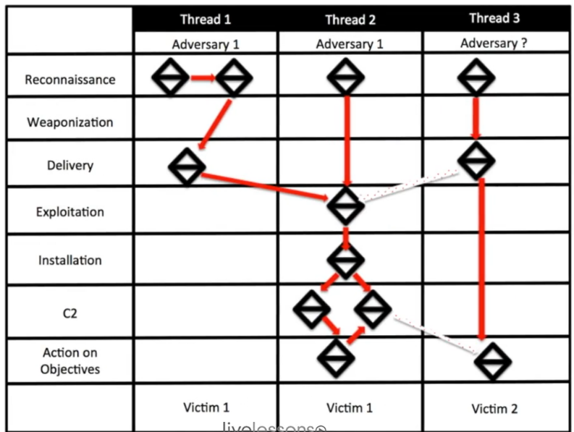
Activity Threads join the diamonds together to map current and future potential attacks.

The activity attack graph highlights the attackers preferences for attack and alternative attacks vectors that might be taken.

Metadata (is not critical to the model) but is mentioned in exam:

Technological (what did the adversary use to deliver the attack)
Socio-political (why the victim?)

5.1 Classify intrusion events into these categories as defined by the Cyber Kill
5.1.a Reconnaissance –
https://resources.infosecinstitute.com/what-is-enumeration/#gref
Port scanning/research (nmap, icmp, telnet, netstat) – any attempt to scan ports.
Social engineering – phone calls/emails/ eavesdropping.
DIG – DNS servers associated with the target.
nMap commands – note the sU sT UDP/TCP respectively, -sV (service detection)
Scan using TCP connect | nmap -sT 192.168.1.1
Scan using TCP SYN scan (default) | nmap -sS 192.168.1.1
Scan UDP ports | nmap -sU -p 123,161,162 192.168.1.1
Scan selected ports - ignore discovery | nmap -Pn -F 192.168.1.1
Detect OS and Services | nmap -A 192.168.1.1
Standard service detection | nmap -sV 192.168.1.1
More aggressive Service Detection | nmap -sV --version-intensity 5 192.168.1.1
Lighter banner grabbing detection | nmap -sV --version-intensity 0 192.168.1.1
Netstat -a (active connections), -r (router table), -s (statistics of IPv4/6)
Netstat -AN
5.1.b Weaponization – Develop and test how the attack will be executed. Example – finding a vulnerability during reconnaissance then researching for an exploit to mount against it.
Nessus can scan and map exploits in a system.
Metasploit helps compile an exploit and contains a number of well-known exploits built-in.
5.1.c Delivery – Delivering an exploit/attack – for example, a backdoor being opened via an .exe sent via email. Or redirecting a target to malicious site, or USB stick with payload on it, social engineering to trick the victim.
5.1.d Exploitation – Launching the attack against the target. Once the exploitation completes, the next step deals with what is delivered via this process.
- Patch management is the best mitigation against this.
5.1.e Installation -successful installation of the weapon and maintaining persistence inside the target system/environment via. RAT (remote access tools), Backdoors, unauthorized VPN sessions, login rights (cred stealing).
This is often overlooked by admins because they’re focussed on IDS/detection of attacks, without considering if an attack is undetected.
5.1.f Command and control – Gaining keyboard access to the breached system, for example listening for a beacon from the targeted machine to signal successful malicious software installation.
5.1.g Action on objectives
Once the system is breached, the attacker may choose to:
Exfiltrate data, listen on the network over time to gather intel, create a launch point for further attacks. DNS tunnelling (Dnscat and DNscat2 can detect tunnelling).
- To defend against this: Identity management to limit what’s available if a system is breached (ISE).Running breach detection software (AMP with retrospective security and Netflow Stealthwatch to baseline network activity.

5.2 Apply the NIST.SP800-61 r2 incident handling process to an event
5.3 Define these activities as they relate to incident handling
5.3.a Identification
Generally identifying an incident is difficult; examples could be users reporting something, IDS devices, log alerting, AMP/Endpoint reporting.
However typically there will be a precursor (rare) or indicator (common)
Precursors: Web server log entries showing someone using a vulnerability scanner, an announcement of a new zero-day vulnerability, a threat from a group/hactivist.
Indicator: AV alert detecting an infected host, audit config change in a log file, an admin see’s filename with unusual char’s, deviation from normal activity on a network.

5.3.b Scoping (Analysis)
Priotize the incident, consider the value of the systems being attacked (can downtime be afforded?) , begin to record the steps taken (logbook).
5 5.3.c Containment
Different containment strategies should exist depending on the type of attack
-Disconnecting endpoint from network, shutting down a device, disable functions. Being aware that some attacks might magnify if they are contained (i.e. host pinging a subnet, if it stops, it deletes all HD data..).
Can also include evidence collection (chain of custody should be adhered to) and documented with chain of custody forms.
Identifying the attacking hosts .
These contain:
Identifying info (mac address, seriel, location, model, hostname, IP)
Name, title, phone # of individuals who collected/handled evidence
Time and data (timezone inc) of each occurrence of evidence handling.
Locations where the evidence was stored.

5.3.d Remediation
Recovery – identifying all affected hosts and mitigating the vulnerabilities that were exploited. May involve restoring from backup, rebuilding systems, replacing files with clean version, patch installation, password policy review, perimeter rulesets tightened.
5.3.e Lesson-based hardening
5.3.f Reporting
Sharing information with third parties, partial, full or responsible disclosure.

5.4 Describe these concepts as they are documented in NIST SP800-86
5.4.a Evidence collection order
Collection methods:
Risks: rootkits might be in the system to prevent volatile data collection (or provide false data). Decisions about whether to crack a password to access a system for collection should also be considered.
Analysts should document exactly what is seen on the screen before collecting (take photos)
All tools should be on a floppy, cd rom or USB drive to be executed. This is the least disruptive way of collecting.
Message digests of each tool used should be computed and stored safely, each step documented (or a script to detail what was executed, with what output), program versions etc. Floppy disks should be write-protected, CD-ROM write-once (ensure integrity of how the tools are stored)
- Identify the sources of evidence (ISP, mobile devices, computers, kiosks, network devices etc)
- Non volatile data first (swap space, RAM, hard disk)
- Take photos of the state a machine was found in (screensavers etc)

5.4.b Data integrity
Follow 3 step plan-
- Develop a plan to acquire the data
  - Prioritise which data to collect first, based on likely value, volatility (volatile data vs non-volatile should be prioritized) and amount of effort required – specialist tools, legal requirements

- Acquire the data – using forensic tools either locally (preferred method) or remotely (over the network) – how much is collected and effort taken is another factor to consider.

- Verify the integrity of the data –

- Create a SHA-1 (minimum) not MD5 message digest of the original and copied data, and proving they match
- Use a write-blocker to prevent anything being written to the original media, during an imaging process (sometimes the image process corrupts the source).

- A chain of custody should be in place to define how the evidence is handled to avoid allegations of mishandling/tampering.
- A detailed log should also be kept at each step of the investigation before it began (i.e. initial state of the device – photographs etc) and then the collection process - tools used, who collected the data – enough to repeat the process later on if needed.
- Other considerations: business loss if critical systems are taken offline to collect evidence

5.4.c Data preservation
- Containment can affect how data is preserved – i.e powering off a WAP to prevent the computing using a network, disconnecting cabled (think about the malware containment issue w/ pinging hosts – there are risks involved too)
- Preservation of original logs – questions may arise about the fidelity of the copying and interpretation process if centralized logging is in place.

5.4.d Volatile data collection
Should be collected before machine is powered down
These types of volatile data might exist in an OS:
- Slack space – memory sometimes allocates ‘overspill’ to slack space, so there’s data stored in memory blocks that applications may not use.
- Free space – free space aka garbage collection – unallocated /residual data can reside here
- Network configuration – the ‘current’ network configuration (not any saved IP settings etc) should be used whenever possible.
- Running processes – these can demonstrate what should/shouldn’t be running (and therefore what was perhaps disabled)
- Open files – recently accessed open files and who opened them
- Login sessions – session duration, who initiated it
- OS Time – time zones can differ between the OS and the BIOS.

5.5 Apply the VERIS schema categories to a given incident
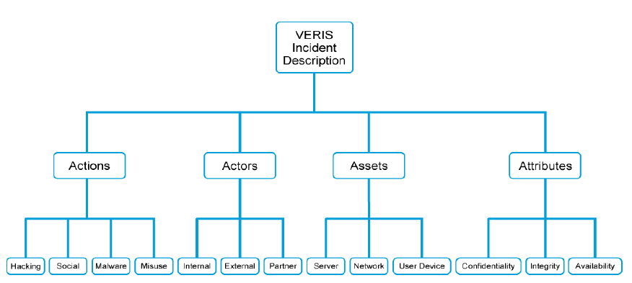

http://veriscommunity.net/schema-docs.html
VERIS focusses on strategic and risk based information.
Incident Tracking: Incident ID, Source ID, Incident confirmation, incident summary, related incidents, confidence rating, incident notes.
Victim Demographics: Victim ID, Primary Industry, Country of operation, State, Number of employees, Annual Revenue, Locations Affected, Notes, Additional Guidance
Incident Description:
Actors (who) – Internal, External, Partner (i.e. vendor 3rd party, a known 3rd party).
Actions – what was the actual attack?
MALWARE
HACKING
SOCIAL
MISUSE
PHYSICAL (theft/snooping/tampering)
ERROR (something left undone/incorrect)
ENVIRONMENT (storm/flood etc)

Assets (what was affected) – Ownership, Management, Cloud, Hosting,
Attributes (how was the asset affected) – CIA triad – how was each triad aspect affected
Discovery and Response: THE DESCRIPTIVE STUFF!
Incident timeline, Discovery Method, Root Causes, Corrective Actions, Targeted vs Opportunistic, Additional Guidance
Impact assessment: Loss categorization, loss estimation, estimation currency, impact rating, notes.

